Running head: FINAL DESIGN REPORT

Device for Acute Hand Rehabilitation after Stroke

Final Design Report
Carly Brown, Sasha Cai Lesher-Perez, Justin Lundell, Mike Socie, Karissa Thoma
University of Wisconsin-Madison
BME 200/300
Client: Michelle Johnson, PhD. Marquette University
Advisor: Professor Mitch Tyler, University of Wisconsin – Madison
13 Dec 2006

Table of Contents

Final Design Report
Executive Summary
Stroke is the number one cause of adult disability in the United States. Rehabilitation centers throughout the United States utilize systems of varying degrees of sophistication to regain bodily function following the hemiplegia caused by stroke. The current rehabilitation systems range from squeezing a ball, to a robotic arm system that mirrors the movements between hands. The aim of this project is to design a system of sophistication that falls between that of the systems previously mentioned. Another aim is to make this a comprehensive device, meaning that it should be universal, in regards to arm size and orientation, and have the capability to be used with a computer interface for patient engagement.

Background Information
Stroke
Stroke occurs in two instances. In the brain, a blood vessel can become blocked or a blood vessel can burst, which interrupts blood flow to the brain in both cases. When blood flow is interrupted, the brain cells in that area of the brain die and brain damage occurs. Effects of a stroke depend on which section of the brain the stroke occurred. Complete recovery is possible after stroke, but more than two-thirds of survivors will have some type of disability. Hemiplegia is a common disability that occurs from strokes. Where the affected side of the body is the opposite of the hemisphere of the brain where the blockage occurred.

Demographics
Stroke can happen to anyone. However, people over the age of 55, being a male, being African-American, Hispanic or Asian/Pacific Islander, or having a family history are at a greater risk of having a stroke. A stroke occurs on an average of once every 45 seconds in the United States. Of these stroke victims, 72% are above the age of 65. Strokes in women are more likely than men to end in a fatality. Even though it is rare, the incidence of stroke in children occurs in three cases in every 100,000.

Rehabilitation
Rehabilitation strategies to focus on upper limb function include neurodevelopment techniques, motor relearning, biofeedback, splinting, constraint-induced movement therapy and robot-induced therapy. Introducing electrical stimulation, such as Functional Electrical Stimulation (FES), into the previous methods has been associated with additional recovery of motor and sensory functions of the hand. Transcutaneous Electro-Nerve Stimulator (TENS unit) provides an electrical stimulation during rehabilitation. A TENS unit delivers electric pulses through electrode skin patches to assist in movement or help deter atrophy. Precautions have to be taken with TENS units because some patients have reported discomfort when the amplitude has been set too high. However, when the TENS unit was at the minimum amplitude level to cause full hand extension, the patients reported no discomfort.
Other studies on upper extremity rehabilitation have demonstrated that mimicry of the impaired he good hand have increased the recovered movement in the impaired hand. This mimicry method uses robot-induced therapy. The good hand does a movement and the device tracks that movement and mimics the movement in the impaired hand with a robotic arm. Using both arms/hands within rehabilitation therapy has been shown to increase the range of motion regained in the impaired limb.

Anthropomorphic Data
There is a great variance of sizes of arms and hands within the population; similarly, there is a difference between the sizes for men and women. The anthropomorphic data gave ranges for two standard deviations from the mean for men and women. The data needed was for the sizes of forearm length, handgrip, and wrist diameter. The data for these were given with heights of men and women. The range of heights for men and women spread from 43” to 78” with the optimum height for women being 58” and the optimum height for men being 74”. The following data was taken from Humanscale, by N. Diffrient, A. Tilley and J.Bardagjy.
Forearm length was measured from the elbow to the wrist. The forearm lengths were 5.8”, 8.5”, 10.6”, and 11.2” from shortest height to tallest. The handgrip was measured from the wrist to the center of grip of the hand. The handgrips were 2”, 2.6”, 3.2” and 3.4” from shortest to tallest. The minimum average wrist diameter was 1.81” to a maximum average diameter of 2.32”.

Design Requirements
The device will be used mostly with patients who are in wheelchairs, so the device needs to be able to work with a wheelchair. The system also needs to be comfortable and non-imposing to the patients. Therefore, it must be lightweight to be attached to a wheelchair and removed after use. Also, the patient shouldn’t be intimidated therefore the device should be small. The device will be used during physical therapy sessions a maximum of three times per day, with each session lasting from 0.5-2 hours. The device must be composed of materials that can be sterilized using alcohol or other anti-bacterial solutions between uses.
Patient engagement is also a key-facet of the design, as the patients should be engaged so that they will want to come back to do their physical therapy. The device needs to have some form of patient engagement beyond the physical motion of the hand. Some form of visual stimulation for the patient should be incorporated into the design.
In addition, the device needs to be universal. It needs to be able to work on either the right or left hand as well as accommodate patients of different arm sizes, within two standard deviations of the average.
The device will also have to allow for the use of a TENS unit. Therefore, since the TENS unit has electrodes that are adhesively attached to the arm, the device can’t impede with the placement of these patches. The TENS unit will be used with patients that do not have the ability to do the extension and flexion of the hand. The complete product design specifications are in Appendix 1.

Preliminary Design
The design will be built upon the surface of an existing wheelchair tray. The standard size for the tray is 24” x 20” and ½ inch thick. The tray clips onto the armrest of the wheelchair to stabilize the tray. The preliminary design consisted of three components: an arm support, the patient-device interface and patient engagement.

Arm Rest
The armrest will be an elevated slope that will secure the arm by U-braces seen in Figure 1. The U-braces will be on a track that will allow them to be length adjustable to accommodate different sized forearms. The U-braces will also be moldable to allow for different circumferences of forearms. The malleability will also allow the arm to rotate but will restrict movement of the arm in the vertical and horizontal directions. The armrest will be connected to the wheelchair tray by a hinge. The armrest will be height adjustable to accommodate the different lengths of forearms for accessing the interface with the device. A shoulder strap may also be needed to restrict the movement of the shoulder, in the case that the patient tries to compensate the movement with their shoulder. A standard shoulder strap would be used that are found in physical therapy clinics.
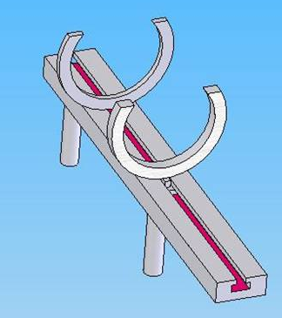
Figure 1. Arm Rest

Patient-device Interface
The preliminary designs that we came up with for patient-device interaction was a t-bar handle, a ball-joystick handle, and a therapy cylinder. The t-bar handle, as seen in Figure 2, allows for the supination and pronation of the wrist. A problem with this design is that depending the finger dexterity of the patient, assistance gripping the device might need to be incorporated.
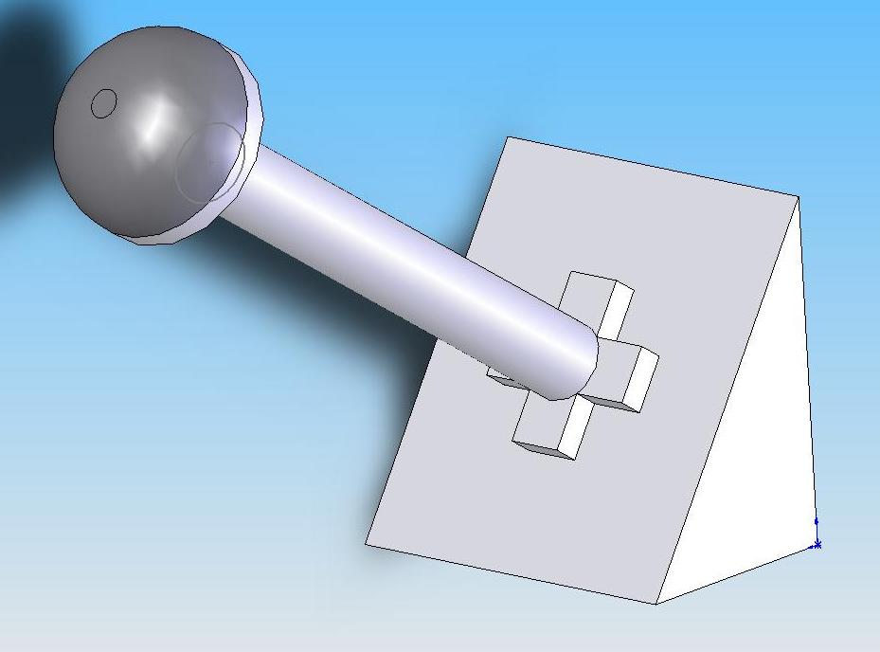
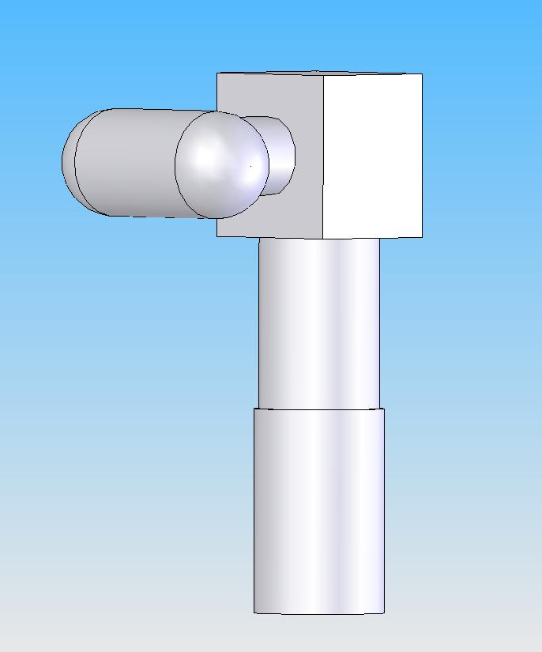
Figure 2. T-bar handle
Figure 3. Ball and socket joystick


Figure 4. Therapy cylinder

The ball-joystick handle, Figure 3, is a ball and socket joint that allows for multiple movements of the hand. The following movements could be done with this type of interface: supination/pronation of wrist, flexion/extension of the wrist, proximal.distal movements of the wrist and flexion/extension of the hand. Even though many movements are possible with this interface, isolating the specific movements could be difficult. Also, gripping the handle could be difficult for some motions due to lack of finger dexterity.
The therapy cylinder returns to the isolated movement of supination/pronation of the wrist. As you can see in Figure 4, the patient will stick their hand between the plates and rotate his/her wrist. The plates would cause little pressure as to not cause discomfort or sores for the patient. An advantage of this system was that it isolated the movement and it did not rely on the need for finger dexterity.

Patient Engagement
Two types of systems were thought about to engage the patient during physical therapy. The first system was a mechanical system that would be like a spin-art game. The system would include a moving arm that would be suspended over a piece of paper that would dispense paint onto the paper while the paper spun. A set up of the system is shown in Figure 5. This system, however, has many moving parts and would be difficult to construct. Also, the system would be messy with the paint and it allows for little variation, which would make the exercise repetitive.

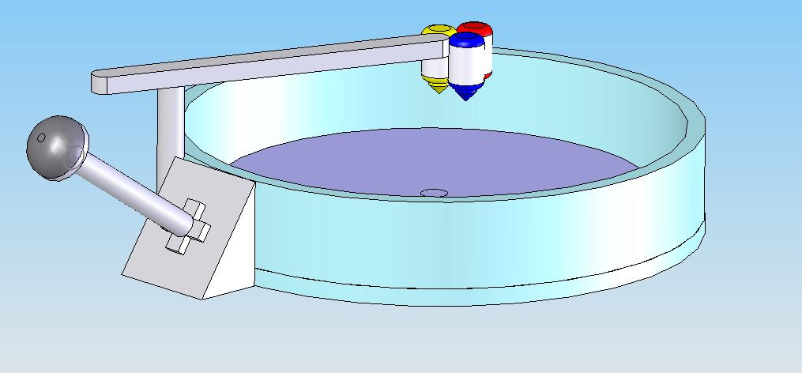
Figure 5. Mechanical patient engagement

The second type of system is a virtual system. The system would be connected to a computer interface that would run either a slide show or a game. The slide show could be changed to allow for different interests for the patient and it could change between sessions. A game interface would allow for a more interactive setting where the patient would have a goal in the game to work towards while working on their rehabilitation.

Design Matrix
In decided which aspect to choose for the preliminary design, a design matrix was constructed. The design matrices grades each element of the design. Table 1 is the design matrix of the options of patient interface. The varieties of movements and sanitation were graded on a scale of 1-3 and the ease of manufacture was graded on a scale of 1-5. The ease of manufacture was graded more heavily to grade the plausibility manufacturing given experiences and time. From the table, the joystick and the cylinder both had similar scores. The preliminary design decided on the cylinder interface because of the isolation of the supination/pronation movement and the ease of manufacturing.
Table 2 is the design matrix for the patient engagement aspect. The varieties of engagement is the ability for the design to change to accommodate different interests of the patient, so that was graded 1-5. The ease of manufacture was again graded 1-5 and the cost was graded 1-3. The virtual engagement was incorporated into the preliminary design.
Our preliminary design, decided to incorporate the armrest with the therapy cylinder as the interface between the patient and the virtual system for the patient engagement.

Patient Interface | t-bar | joystick | cylinder
variety of movement (1-3) | 1 | 3 | 1
sanitation (1-3) | 2 | 2 | 2
ease of manufacture (1-5) | 2 | 2 | 4
TOTAL | 5 | 7 | 7
Table 1.

Patient Engagement | mechanical | virtual
variety of engagement (1-5) | 1 | 5
ease of manufacture (1-5) | 1 | 3
cost (1-3) | 1 | 1
TOTAL | 3 | 9
Table 2.
Design Changes
After meeting with our client and showing her the proposed design, changes were made to the design specifications. Our client wanted an active system to employ the supination/pronation of the wrist while the TENS unit would activate the flexion/extension of the hand. The hand would then grasp an existing joystick that would eventually be interfaced with a computer.

Final Design
After that client meeting, the final design was changed to incorporate an active system along with an electro-stimulation system. The active system will allow help with the supination and pronation of the wrist, if the patient doesn’t have the ability to do that movement. This design will still worked off the platform of a pre-existing wheelchair with the moveable pegs for universal use.

Active System
The final design kept the idea of a cylinder for the supination/pronation of the wrist. The cylinder is placed around the wrist and it is connected to a motor that will rotate the cylinder. Figure 6 shows the active system. As you can see, the cylinder is lined with memory foam that will allow for the different sized wrists of patients. The foam also secures the wrist in the cylinder. The motor that was used for the prototype
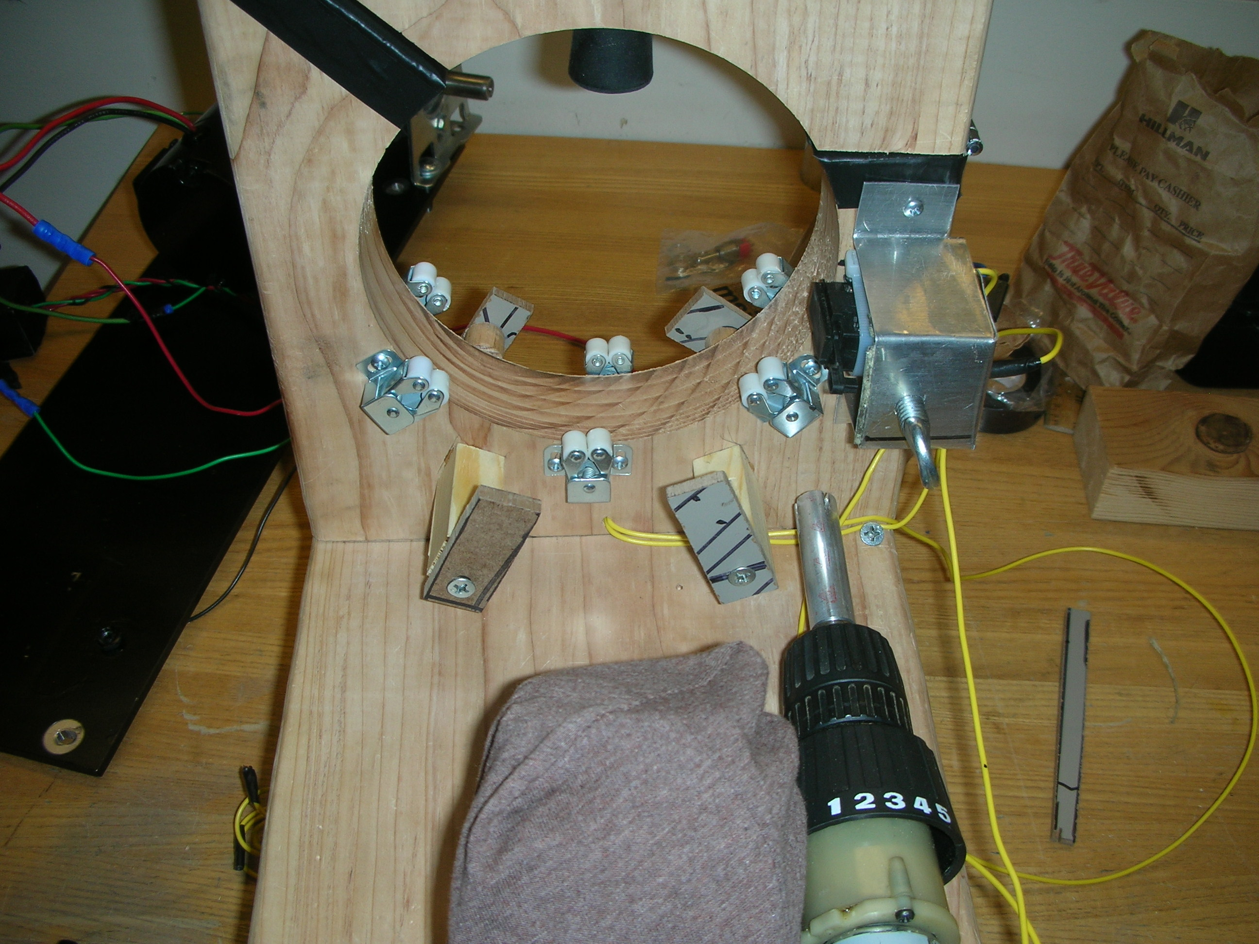
Figure 6. Active system of final design

was a motor and switch from an electric drill. The motor has different speed capabilities, along with the ability to change directions from the switch.

On the outside of the cylinder, there are fingers that will flip the switch to change the direction of the motor. The fingers were placed so that the wrist would rotate about 75˚ in one direction, the finger would flip the switch to change directions of the motor, and then the wrist would rotate about 75˚ in the other direction, where another finger is placed to change directions again. An on/off switch located on the base of the cylinder controls the power for the motor. This gives the control of the rehabilitation session to the patient so the physical therapist doesn’t need to be watching over the patient the entire time. A physical stop was also added above the cylinder to ensure the safety of the device.

Electro-stimulation system
The active system will be used in accord with a TENS unit to stimulate the extension of the fingers. The electrode pads will be placed over the radial nerve. Figure 7 shows a diagram of where the radial nerve runs along the arm. The pads will have to be placed on the patient by the physical therapist. Given the placement of the pads, the system will not impede with the placement of the electrodes. Also, the function of the electrodes will not be compromised given the material that the prototype is made out of.
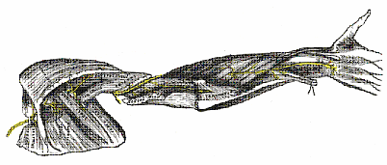
Figure 7. Radial Nerve in yellow

Universal Use
The system is contained as one, moveable piece. The cylinder, motor, and joystick are on a board that is on four pegs. These pegs are then inserted into holes that are drilled into the wheelchair tray. There are multiple sets of holes for the pegs to move between, so the system can accommodate the range of forearm sizes amongst adults. The pegs can also be placed on both sides of the board to accommodate either arm, since stroke can affect either arm.

Budget
The given budget for this project was $750. Given the late changes in the design, a rough prototype was made from wood and donated materials. The prototype ended up costing $116.28. Appendix 2 has a table of the break down of the costs of the device.

Future Work
Given the time restraint of the project, many improvements would like to be made to the device. The first improvement would be to make the device out of aluminum or plastic instead of wood. This would make the device lighter weight, which would increase the portability of the device. It would also make the surface easier to disinfect between uses, since multiple patients in a hospital will use it.
The second change for the design would be to incorporate a new motor and microprocessor. A microprocessor would be programmed to rotate the motor a certain number of degrees, stop it and then reverse the direction. The microprocessor could also be programmed for different speeds for different levels of physical therapy.
Eventually, this system will be connected to a virtual interface. The interface will be dependent on client and patient preferences. A virtual system that was thought of for the preliminary design would be used.
Testing will also have to be done on the system to see how it performs in physical therapy sessions and with patients.
Appendix 1
Product Design Specifications
This device will assist in hand rehabilitation in stroke victims in the first three months after stroke. The device should use FES to assist in the supination and pronation movements of the wrist.
Stroke is the leading cause of long-term disability in the United States. Hand impairment is prevalent in stroke patients and is particularly debilitating since it limits independence and the ability to use the hand to do real tasks like eating and drinking. The goal is to design a device to facilitate hand rehabilitation in the acute phase, the first 3 months, after stroke.
Design requirements:
- easily to attach to the impaired arm
- comfortable to wear
- accommodates various sized hands and forearms
- attach to either the left or the right arm
- portable and mobile to be used while seated in a wheelchair
- use functional electrical stimulation via an existing TENS unit, FES
- use electromagnets to assist in grasp and release of an object
- pronation and supination motions of the wrist

1. Physical and Operational Characteristics
a. Performance Requirements- The device will be used during physical therapy sessions. The sessions will be 3 times a week, for a maximum use time of 2 hours per sessions, and the sessions will continue for 6 weeks. Also, no more than 3 patients will use one device within a therapy session. So, the device will be used on an average of 18 hours a week. Loading and unloading of the device onto the wheelchair will be done by a physical therapist. The device should be able to be used on either arm and be used with a wide range of arm sizes. The device will focus on the supination and pronation movements of the wrist.
b. Safety- The FES should not cause discomfort to the user. The device should be easy to use for sanitary reasons. Also, the device should not impede with the movement of the wheels of the wheelchair.
c. Accuracy and Reliability- The device should allow for 270˚ rotation. The device should be able to rotate repeatedly for the durations of the sessions without change in rotational resistance of the device.
d. Life in Service- The system should work for 3 years, after that time the system would be replaced with a new system. The battery life for an alkaline battery in use is 140 hours.
e. Shelf Life- The shelf life should be able to sit on a shelf for 10 years. The only component that would have a shorter shelf life would be the battery, which is easily replaced.
f. Operating Environment- The device will be used within a hospital, in a clinical setting. It will be used indoors.
g. Ergonomics- The range of sizes of our device will fall within 2 standard deviations of the average size arm. Be able to accommodate any size arm without causing discomfort, itching. Also should not debilitate arm function by being strapped into a fixed position. The device should also be allowed to be adjusted and released by their good arm.
h. Size- Work within the confines of a desktop for a wheelchair which is the size 24” x 20”, and also attach our system to any part of the wheelchair. The maximum volume of our device will be 24”x 20”x 18”.
i. Weight- Less than 15 lbs
j. Materials- Hypo-allergenic materials that are easily cleaned.
k. Aesthetics- Should not be intimidating, unimposing, and interactive.

2. Production Characteristics
a. Quantity- 1
b. Budget- $750.

4. Miscellaneous
a. Standards and Specifications- Since our device will be in the prototype phase, there are no FDA regulations that govern our project.
b. Customer- The user of this device will be within the age range of 45-80, so the device should be geared toward that audience. Variations could be made to the system to accommodate other ages.
c. Patient-related concerns- sterilization
d. Competition- A BME design group from Marquette University.

Appendix 2
Item Description | Supplier | Quantity | Unit Price | Shipping | Total Cost
Masonite Wheelchair Tray | www.1800wheelchair.com | 1 | $27.99 | $9.00 | $36.99
Joystick | www.tigerdirect.com | 1 | $14.99 | $7.99 | $22.98
Memory Foam | www.efoamstore.com | 1 | $12.00 | $6.00 | $18.00
Strap Hinge | Home Depot | 1 | $2.09 | $0.00 | $2.09
2" x 10" wood board | Home Depot | 1 | $12.68 | $0.00 | $12.68
5/8 dowel | Home Depot | 1 | $2.59 | $0.00 | $2.59
Aluminum Tube | Home Depot | 1 | $3.59 | $0.00 | $3.59
Screws | Home Depot | 1 | $1.57 | $0.00 | $1.57
Rollers/Cabinet holders | Home Depot | 7 | $0.89 | $0.00 | $6.23
Bolts and screws | Truvalue Quality Hardware | 15 | $0.25 | $0.00 | $3.75
Gorilla Glue | Truvalue Quality Hardware | 1 | $5.79 | $0.00 | $5.79
TOTAL |  |  |  |  | $116.26
Total costs of the prototype
References
Burgar, et al. Development of robots for rehabilitation therapy: the Palo Alto VA/Stanford
Experience. Journal of Rehabilitation Research and Development Vol. 37: 663-673.
Diffrient, N., Tilley, A., & Bardagjy, J. (1981). 7. Standing and sitting at work. Humanscale.
National Stroke Association. (2006). www.stroke.org. (Dec 1, 2006).
The American Heart Association (2006) www.americanheart.org (Oct. 17, 2006).
Yozbatiran, N. Electrical stimulation of wrist and fingers for sensory and functional recovery in
actor hemiplegia. Clinic Rehabilitation. Volume: 20: 4-11.

National Stroke Association (2006) www.stroke.org
The American Heart Association (2006) www.americanheart.org
National Stroke Association (2006) www.stroke.org
Yozbatiran, N. “Electrical stimulation of wrist and fingers for sensory and functional recovery in actor hemiplegia.” (2006). Clin Rehabil. Volume: 20, Issue:1, Pages:4-11
Burgar, et al. “Development of robots for rehabilitation therapy: the Palo Alto VA/Stanford experience,” (2000). Journal of Rehabilitation Research and Development Vol. 37 No. 6

