Medical Aspirator

Problem Statement
Most developing world hospitals do not possess operating suction machines; yet, they are required for many procedures. The main problems are the lack of available spare parts, the cost of a replacement unit, and dependence on consistent electricity. The objective of this project is to design and develop a medical grade aspirator to be manufactured inexpensively from locally available materials. Along with the device, an instruction manual will be produced to allow for proper usage and care in the future.

Table of Contents
Background Information 1
Project Specifications 1
Current Devices 2
Previous Design 3
Design Alternatives 4
Positive Displacement Pump 4
Advantages 5
Disadvantages 5
Turbine 5
Advantages 6
Disadvantages 6
Venturi Tube Design 6
Advantages 8
Disadvantages 8
Water Piston 9
Advantages 10
Disadvantages 10
Decision Matrix 10
Future Work 12
References 12
Appendix 13

Background Information
Aspirators are used in a clinical setting to remove blood, mucus, and other bodily fluids from patients. Aspirators are common and critical tools in the operating room. By removing fluids they allow surgeons to see what they're working on. The key components of an aspirator are a disposable collection tip and a removable collection container. United States hospitals use wall suction, where tubing and a collection chamber are connected to a wall outlet powered by a large central vacuum pump.

Most aspirator applications require high suction, such as the removal of mucus and blood. However, there exist a few special cases where low flow rates and suction are required. Gentle intermittent suction is required for the removal of gastrointestinal obstructions, since powerful suction would pull the coelom wall and block the aspirator tip. Another procedure requiring low-suction is meconium aspiration, when the earliest stool of an infant is removed to prevent meconium aspiration syndrome. Meconium aspiration syndrome (MAS) occurs when infants take meconium into the lungs before or during delivery and causes the infant to develop pneumonia, so low levels of suction are required to remove this health risk while avoiding suction of fragile fetal tissue. So while high suction is needed in most procedures, variable power controls are common in order to accommodate these special low-suction procedures.

This project is a special case for the design of an aspirator. The purpose of the project is to make instructions for the construction of an aspirator from materials which would be locally available in a developing world country. The electrical power for these hospitals is produced by generators which are unstable and frequently malfunction. Trained medical staff is also limited, so it is important the device is simple to use even by untrained personnel. Aspirators are usually powered by 120 VAC outlets, batteries, or a combination of both.

Engineering World Health (EWH) is a non-profit organization of engineers which evaluates the needs of hospitals in developing world countries, then accommodates them in providing them with refurbished medical equipment. They also help in training the medical staff in the use and maintenance of the equipment in order to improve the capabilities of the hospital for years to come (“Engineering World Health,” 2008).

Project Specifications
In order for this device to be relevant for a clinical setting in the developing world, the design must follow several criteria. First and foremost, the device must safely remove fluid from the surgical field. Additionally, the device must be constructed and maintained by locally available materials. Specifically, there are several technical benchmarks which this design will have to achieve. The device must reach an adjustable suction of up to -550 mmHg (gauge). Also, the device must be able to evacuate 15 L/min through the suction tip. These two standards bring an important facet of the design into focus. The suction strength of the design will determine whether or not the pressure benchmark is reached, while the rate at which it can replenish the vacuum will determine the flow through the tip. In order to achieve the vacuum required, some sort of energy transducer (i.e. pump) will need to be used. As a reliable power grid is not available in the developing world, the device must run off of a 12 VDC battery. Since surgeries can last for up to eight hours, the energy drawn from the device must not exceed the energy rating of the battery. Although the device will be designed to last for an entire surgery, a superior design will include a mechanism to create a vacuum in the event of power loss.

Since the device will be implemented in the developing world, the materials from which the device will be built must be “locally available.” For the purpose of this design, locally available materials will be limited to salvaged car parts, UW-SWAP materials, and basic hardware store purchases. Also, the ergonomics of this design will be important since it will be used in an operating room. The operating room environment requires a low profile device which does not introduce pollutants into the air. While no specific size or weight restrictions are imposed on the device, the device should not interfere with operating room use. Preference is for a device that takes up minimal floor space, resulting in it likely being taller than it is wide. If the device weights more than 10 kg, it should include some means for movement inside the hospital such as wheels. The device should include an autoclavable collection vessel and suction tip.

These criteria define significant restraints for the design process, but will ultimately produce a practical and safe device to use within the clinics of the developing world. The device, if chosen by EWH, will be used in surgeries to save countless lives.

Current Devices
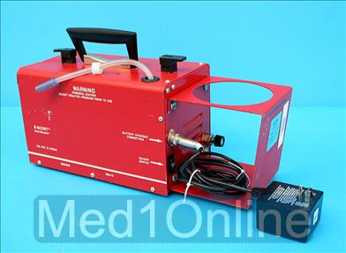
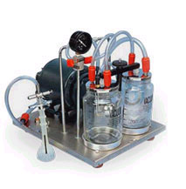
Ignoring irrelevant large wall suction units due to low-power requirements of this project, there are a handful of portable aspiration units. The aspirator in Figure 1 is made by Supreme Enterprises. It has a capacity of -710 mmHg (gauge) ± 10 at 25-30 L/min. It is a 180 watt device which runs on 110 V AC. Although it is small and portable it still requires wall power (“Portable suction units,” 2008). Figure 2 is a 12 VDC battery operated suction pump. It is a diaphragm type pump and can produce a variable vacuum between 50-525 mmHg (gauge) and achieve airflow rates as high as 30 L/min. However the unit costs $700 (“Portable vacuum aspirator,” 2008). SSCOR also produces less powerful models as inexpensive as $300, still well outside of the proposed materials price of $100 set by Engineering World Health. These aspirators are inaccessible to developing world countries because of their price, and they are difficult to maintain since specialty spare parts are hard to obtain when the devices fail. In these situations, advanced circuitry and specialty parts make these devices practically irreparable.

Figure 1. Portable suction unit from Supreme Enterprises.
(“Portable suction units,” 2008)

Figure 2. Battery operated portable suction unit manufactured by SSCOR.
(“Portable vacuum aspirator,” 2008)

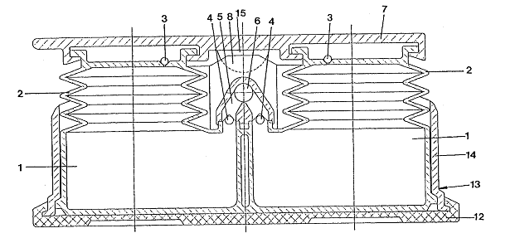
In a search for patents, one seemed the most applicable to this project. U.S. Patent No. 5,934,888 describes a human powered aspirator pump as shown in Figure 3. It functions by alternating the compression and expansion of the two chambers by stepping on them, and creating a vacuum with the help of one way valves. The two spaces are connected through a common manifold with a connection for the suction tube of a catheter. One way valves at the entrance of each large hollow space close when the pressure in the hollow space is greater than the pressure in the common manifold. This design is relevant because it produces suctions without the need for electric power. However the goal of this project is to create an aspirator from salvaged or locally available materials. A device like this would need to be custom manufactured.
Figure 3. (U. S. Patent No. 5,934,888) "Aspirator Pump" This design makes use of a bellows-style design to create suction in both chambers, labeled “1.”

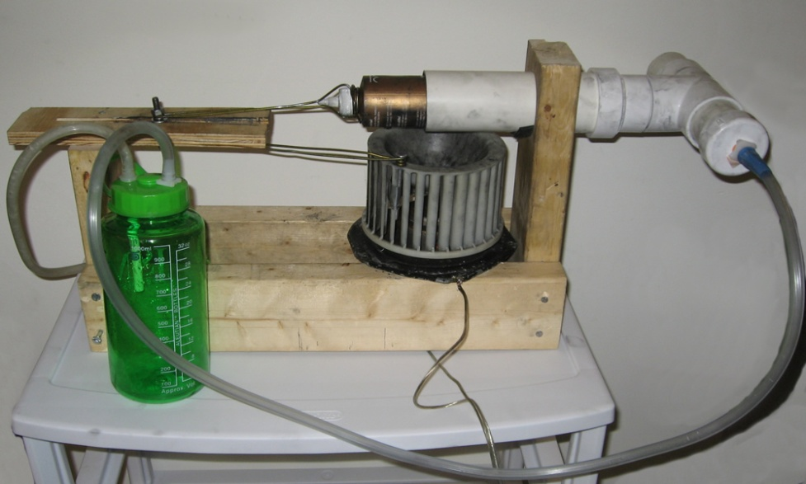
Previous Design
Figure 4. The image above displays the final design, including the fan motor, piston arrangement, and collection flask.
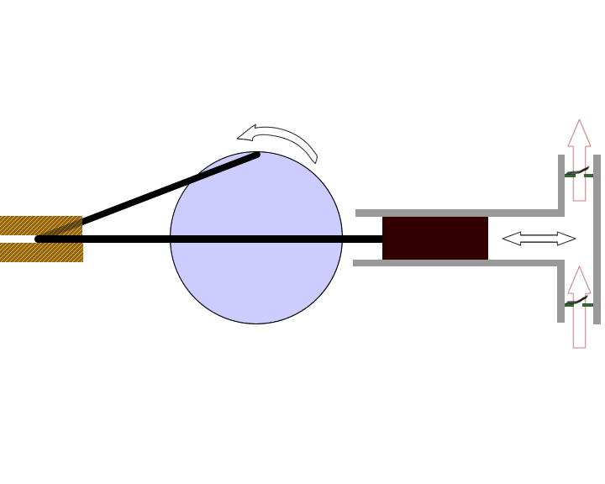
Developing suction system intended for the developing world has actually been an ongoing project for the Biomedical Engineering Department at the University of Wisconsin-Madison. Last semester’s device was a piston-based design using an adapted car heater fan, as shown in Figure 4. The fan is powered by a standard 12V battery and is connected to the piston using a pin connection, which uses two rigid coat hanger arms to convert the radial motion of the fan motor into linear motion. One arm rotates with the motor while the other moves back and forth along a straight slot, cut through a piece of wood, which is dimensioned to be the stroke length corresponding to the diameter of the fan motor (Figure 5). Through the linear motion of the piston, air is alternately drawn and expended through two check valves at either end of a PVC pipe. The valves are oriented such that when the piston is pushing air in one direction, one valve opens while the other is pulled shut. The inlet check valve connects to a collection chamber and an autoclavable suction tip.
Figure 5. As the fan motor rotates, it forces the motion of a pin-connected rod along a wooden slot. This linear motion along the slot actuates the piston, which alternately suctions and expels air through a section of PVC pipe.

The advantages of the design were that it was very cost-effective, compact, and used locally-available materials. However, testing results indicated it was unable to draw sufficient volumes of fluid or air to meet product specifications nor could it generate sufficient vacuum pressure. Air flow was tested using a clinical flow meter and was found to be approximately 12 L/min, while liquid flow was tested by measuring water displacement over time and the average value was approximately 1.51 L/min. A pressure test revealed the device was capable of drawing 76 mmHg instead of the requisite 550 mmHg, leaving room for improvement in a new design.

Specific features that contributed to the inefficiency of the design included the leaky one-way valves, which were made from pieces of flimsy inner-tube rubber and tin can lids, in addition to the power inefficiency, which was largely caused by the necessity for radial to linear motion conversion rather than one type of motion. Finally, the utility of the piston was limited by its failure to fit snugly in the PVC tubing, despite the use of a graphite lubricant. The lubricant itself was messy and was unable to maintain a uniform seal around the piston walls. In our survey of the design, we realized that it would be difficult to modify the existing components, so we chose to pursue significantly different design approaches.

Design Alternatives
An apparent dichotomy exists between our two primary design constraints of creating high levels of negative partial pressure while minimizing electric current from an external battery source, so we generated designs that primarily aimed to achieve a balance between these two parameters. Our four designs described in the following sections illustrate how common techniques for generating suction can be applied in ways that overcome many of the limitations posed by the unique environment of a third world medical clinic.

Each of the designs would be connected to a collection flask and suction tip. The suction tip will be autoclavable, and its purpose is to draw up any patient waste or fluids. This matter enters the tube, passes through a section of flexible tubing, and is stored in the collection flask. We have learned that the collection flask must be at least 2 L in volume to meet standard hospital regulations.

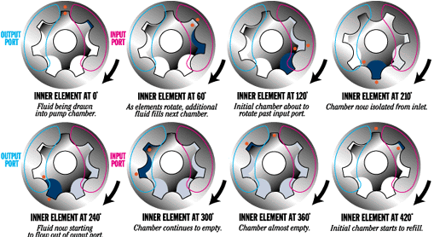
Positive Displacement Pump
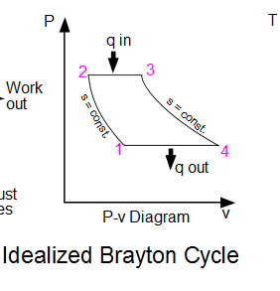
A positive displacement pump is defined as a pump which physically traps a substance and transfers it to a different location. The previous semester’s design is an example of such a pump, although the previously listed design flaws limit its functionality. However, the concept of a positive displacement pump provides an effective mechanism to generate vacuum pressure. Since air is physically removed from the system, this configuration will be efficient. There are several different pumps which fall into the category of positive displacement. The gerotor pump is one such design. It consists of two gears; the outer has N teeth, and the inner has N+1 teeth. This set configuration can be seen in Figure 6.
Figure 6. This figure shows the cycle of a gerotor pump and demonstrates how it generates vacuum through angular motion.
http://www.irisengineering.com/about.html

As the inner gear rotates a volume of air is drawn through a port and into an expanding chamber, creating a vacuum. The volume of air expands to a maximum point, and then becomes sealed by the junction of two rotor teeth. Finally the volume of air begins to contract and is forced through an outlet port. Figure 7 shows the pressure-volume curve for this work cycle, known as the Brayton cycle.

The gerotor pump can be found in the oil pumps and power steering units of a car and are normally driven off of the crank shaft. This type of pump has the benefit of being internally sealed, thus eliminating the need to create one way valves.
Figure 7 shows the idealized Brayton cycle, on which the gerotor pump operates.

Advantages
The positive displacement pump design has several advantages regarding its implementation in the developing world. These pumps are found in and easily dissected from automobile engines. Because the inner and outer gears are literally made for each other they form a nearly perfect seal with one another, thus greatly contributing to the efficiency of the design. Although these pumps generally do not move large amounts of air at once, they can rotate very quickly, thus generating the vacuum required for the design to be effective. Finally, this mechanism of vacuum generation lends itself to a manual backup. The pump requires rotational energy to operate, and thus a bicycle or other rotating manual source could be used to actuate the pump should the battery fail.

Disadvantages
This design is not without flaws which need to be addressed before it could be implemented into the clinical setting. The gerotor pump is generally used to move fluids which are less compressible than air. This contributes to the efficiency of the design by allowing the fluid itself to help form the seal between gears. Also, the most desirable aspect of this design – the teeth that meet to effectively seal the chambers – is also a weak point in its design. Metal-metal contact at such high rotational speeds as this device will be subjected to must be lubricated so that metal slivers do not grind off of the teeth. Also, a significant amount of torque will be needed to generate the vacuum required.

Turbine
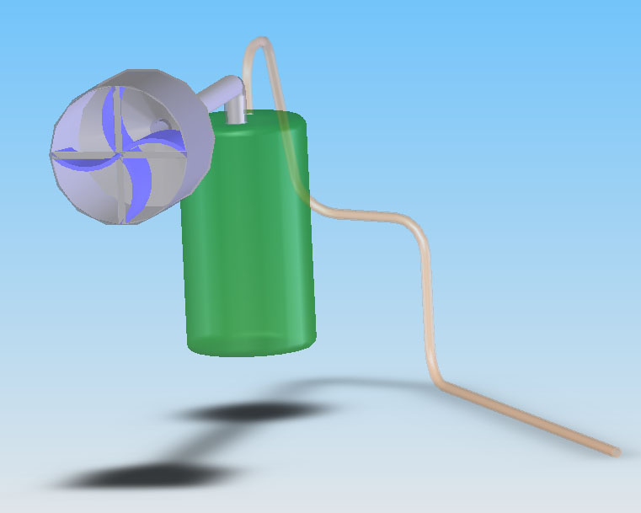
This design uses a turbine or fan pump to move air and create suction. As shown in Figure 8, a rotating fan creates a region of reduced pressure behind the fan blades. As an example, a one horse-power Shop-Vac has an airflow rate of 120 ft³/min with a pressure of 101 mmHg (gauge). The fan of a turbine pump functions similar to the propeller of airplane. Unfortunately the efficiency of the system is a function of the fan’s diameter as seen in Figure 9. The line furthest to the right in the figure represents a propeller with a large diameter (where the power to diameter ratio is small). In this case, even at low speeds the propeller maintains a good level of efficiency. As the lines progress to the right, the diameter of the propeller decreases and higher speeds are required to maintain the same level of efficiency. The most efficient setup is a large diameter fan blade, but the efficiency can be compensated for by running the propeller at higher speeds. In the case of a fan driven pump in an operating room, a small fan would need to be used to keep a small footprint. Consequently, the fan would need to be run at high speeds.
Figure 8. Schematic representation of a turbine driven aspirator. As shown, the turbine itself is connected to the aspirator collection flask, which draws suction using the rpm of the turbine motor.

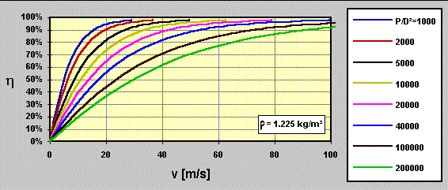

Figure 9. A graph of efficiency vs. propeller speeds for different power loadings in [W/m²] (power over diameter).
(“How a propeller works,” 2008).

Advantages
The advantage of using this type of pump is that they are quite common. Leaf blowers and vacuum cleaners use turbine pumps to move air. The idea is to salvage a turbine pump from an appliance such as a vacuum cleaner and modify it to run on a 12 VDC car battery. The design does have the potential advantage of being small. Space is limited in an operating room, especially around the operating table. If the device cannot be placed remotely it needs a small footprint and this is a minimalistic design.

Disadvantages
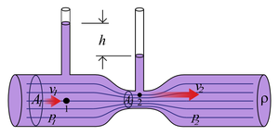
One disadvantage of this design is the high RPMs small fans must run at to maintain suction. This could lead to issues with noise. Turbine motors also rely on air moving over them for cooling. While the device is suctioning fluid, little air will be moving over the turbine pump so the motor could overheat and fail. However, reliability is an important parameter in our design. Another disadvantage of a turbine system is the level of suction it can produce. Unlike positive displacement pumps, the push on the air by the fan blades reaches equilibrium with the pull of the vacuum, so there is a maximum obtainable vacuum pressure for turbine systems. There is also an extra safety consideration with this system. The motor to spin the turbine at high speeds would likely produce a lot of heat and there is the possibility of the motor's heat sink causing contact burns if someone were to brush up against it.

Venturi Tube Design
A venturi tube is used to form partial vacuums for a diverse array of fluid and gaseous applications, from spray atomizers to carburetors and, additionally, they can be used as sensors for fluid flow measurements. This diversity of applications lends itself toward a wide range of materials and sizes available for venturi tubes. However, all venturi tubes are grouped together by a common geometry as shown in Figure 10.
Figure 10. Classically, a venturi tube’s geometry resembles the one in this figure, where fluid enters in a region of wider diameter and passes into a region of smaller diameter. This elicits a pressure drop.
Fluid flow through the chambers of the tube is a function of the inner diameter. This is governed by the Bernoulli Principle, which states that for an incompressible liquid fluid speed increases with a corresponding decrease in pressure or increase in potential energy. The Bernoulli Principle is defined by the equation for the fluid characteristics at a point
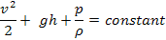
where v is the horizontal fluid velocity, g is the gravitational constant, h is the distance between a reference plane and the point where pressure is being measured, p is the pressure at the point, and ρ is the density of the fluid.
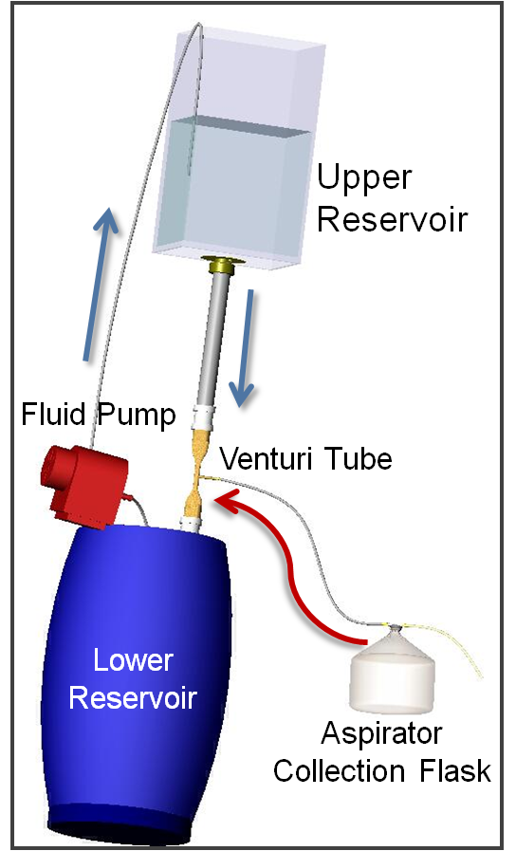
In addition, another equation can be applied to venturi tube systems, called the continuity equation. Whereas the Bernoulli equation is an application of conservation of energy, the continuity equation is a restatement of the conservation of mass. If the velocity of a fluid increases, the equation states that the volume passing through the system must remain constant as long as the fluid density remains constant. In other words, as the volume of a system changes, fluid flow will change accordingly so that the volume passing through the region over time is held constant. This relation can be summarized by the equation
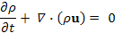
where ρ is the fluid density, t is time, and u is the fluid velocity.

By combining both the Bernoulli equation and the continuity equation, we find that as the diameter of a vessel decreases the fluid velocity increases to maintain conservation of volume while the pressure decreases to maintain conservation of energy within the system.

In a venturi tube, a tap is placed in the narrower portion, since this region is of lower pressure and is capable of drawing suction. The tap draws air, which then mixes with the fluid passing through the tube, and this mixture flows into a wider portion of the tube where pressure is elevated to atmospheric pressure once more as it passes out of the tube. The key feature of venturi tubes is to create appropriate dimensions of the different chambers in order to effect appropriate changes in pressure. As shown in the Bernoulli equation, the fluid velocity entering the tube and the tube’s elevation are also contributors in determining the pressure at the tap.
Figure 11. The venturi tube design would require an arrangement shown in this figure. The blue arrows indicate the direction of fluid flow, while the red arrow indicates air flow.

In our design, we plan to create a system that will provide a constant supply of fluid to pass through the venturi tube. As shown in the diagram (Figure 11), the fluid leaves a lower reservoir and is pumped upward by a motorized pump into another collection reservoir. Then, the fluid is gravity-fed through the venturi tube and back into the lower reservoir. The open system allows any air drawn into the tube to escape downstream from the tap.

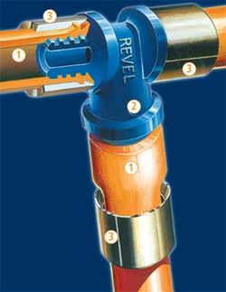
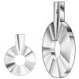
The development of the venturi tube itself is paramount to the functionality of the device. We have several ideas of how to create our venturi tube, but ultimately its nuances will be determined through testing. One such idea would involve stretching a piece of heat-treated PVC pipe, which would create the smooth contours observed in our diagram. Furthermore, it could be created by assembling separate pieces of PVC pipe and using a T-connection to create the vacuum tap. Alternatively, we could assemble it as an orifice tube (another variation of the venturi tube), by inserting a plate with a hole cut through it between two segments of pipe. This orifice plate, as it is called, would be at least an inch thick and would have a tap drilled normal to the hole to serve as the suction tap, as shown in Figure 12. Orifice tubes may also be salvaged from the air conditioning unit on a discarded automobile.
B

We were able to test the capabilities of a venturi tube-based design by setting up a simple apparatus in an organic chemistry lab at UW-Madison. The collection vessel was connected simultaneously to a tap in the building’s water line and to an analogue pressure gauge. When the water was turned on, the gauge was monitored and the pressure was recorded to be approximately 650 mmHg (gauge) of suction. We also recorded the volume flow rate required to sustain this pressure to be 5.4 L/min. This indicates that a relatively small volume flow rate would be required to attain and maintain this high level of suction.
Figure 12. (A) The orifice tube is a junction between two segments of tubing of larger diameter. The blue component in this figure illustrates one example of an orifice plate, with the tap portion marked 2. (B) Another example of an orifice plate that is more streamlined. The plate is bolted between two segments of pipe.
A

Advantages
There are many advantages to a venturi tube system, especially in its efficient generation of suction. As shown from our preliminary testing data, the venturi tube is capable of translating high fluid velocity directly into high suction. Although our design incorporates a battery-operated pump, this mechanism can theoretically function by manually adding water to the upper reservoir. This feature is favorable because it offers the opportunity for a manual backup if the power supply should fail. Also, the suction generated by this system is capable of meeting hospital suction standards, which is an essential part of our design considerations this semester. Finally, the materials used in this design are basic as well as flexible. Other than the venturi tube component itself, none of the other materials are specialized and should be found locally. The pump component is intentionally nonspecific with the flexibility of being salvaged from a car or a household appliance.

Disadvantages
The main disadvantage of the venturi tube design is it will be bulky because the design requires two reservoirs and mandates an elevated arrangement. This property may make it difficult to integrate into an operating room setting, since space may be limited. Similarly, the design requires significant assembly in order for it to operate, so it may be more difficult to communicate the assembly process in an easy-to-follow user manual. Finally, the fabrication of the venturi tube may be a setback to the implementation of this device.

Water Piston

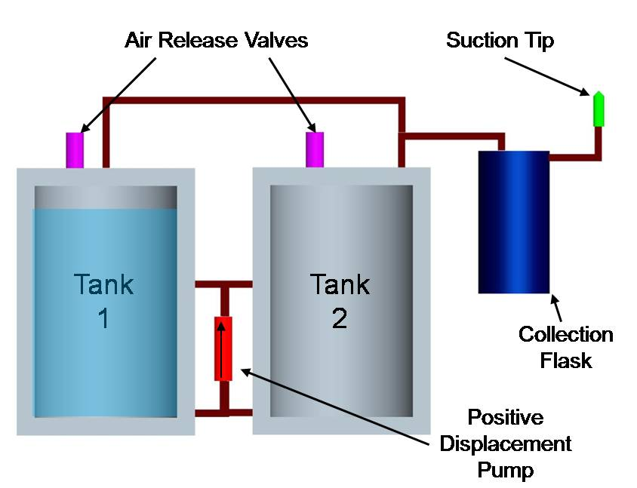
Valves
a & b
Valves c & d
Figure 13. This picture demonstrates the components required for the water piston design. The water is completely located in Tank One, which indicates that it is at the beginning of the vacuum cycle.

This design is based around negative pressure created by evacuating tanks of water in a closed system. The water level in each tank mimics the activity of a piston head, giving this design its name. As the water level is lowered, negative pressure is created in the top of the tank, drawing air in. This effect is equivalent to using a mechanical piston to create negative pressure (as in the previous semester’s design). However, using water instead of a mechanical piston has some advantages as far as sealing, which will be discussed later. Figure 13 shows the layout of the design.

During operation, water is evacuated out of tank 1 into tank 2 by means of a positive displacement fluid pump. Valves a and c are closed while valves b and d remain open during this phase to permit water movement in only the desired direction. Also at this time, the one way valve on tank 2 opens to allow air to escape while water fills the tank. As tank 1 is evacuated, air is drawn through the tubing, collection flask, and suction tip, producing aspiration. One-way valves at the tubing-tank connection ensure air can only move into the tanks and not out via the tubing.

Once all the water in tank 1 has been removed, the flow direction must be changed manually. To do so, the pump must be disengaged while valves a and c are opened and valves b and d are closed, switching the direction of water flow from tank 2 back to tank 1. Once all valves have been properly set, the pump may be turned on again, now creating negative pressure in tank 2 that pulls air and creates aspiration through the suction tip.

The design would use locally available materials, since 60 gallon drums are generally readily available, and they are the major components relied upon in the design. As in the other three potential designs, the pump could be salvaged from a discarded automobile, and the tubing size is irrelevant to its performance, so it could be either PVC pipe, copper pipes, or any rigid tubing found in a hospital setting. Since the one-way air release valves would be on the exterior of the device, their size and shape is flexible and they could be constructed in a similar manner to last semester’s design (using a leaflet valve design comprised of a pressure-sensitive, flexible flap affixed to a more rigid base). The valves associated with the pump and collection vessel would require more specific characteristics but could most likely be acquired from salvaged car parts.

Advantages
There are two main advantages to this design. First, this design uses energy efficiently because it involves only one fluid pump. This is in contrast to the previous semester’s design, which required conversion of radial to linear motion to operate. A lack of energy conversions like this makes this design more energy efficient. Second, by using fluid as if it were a piston, the issue of sealing around the piston head is resolved. In typical piston design, a major cause for inefficiency is leaking at the interface of the piston head and the casing. By using fluid as the piston head, this leaking cannot occur because the fluid will always expand to touch the walls of the tank all the way around, leaving no place for a vacuum to escape.

Disadvantages
One major disadvantage of this design is its potential to be too bulky to implement in an operating room setting. This design requires two 60 gallon drums, which take up significant space and could interfere with the medical staff’s ability to navigate the operating room in a safe and timely fashion. Another disadvantage of the water piston design is it will aspirate in pulses because the pump direction must be reversed. Another disadvantage is switching valves requires the attention of the medical staff. Therefore, during these periods, not only is the aspirator nonfunctional, but the medical staff would have one less person to carry out activities associated with whatever procedure was going on. The final disadvantage of this design is its inability to run via manual backup in the event electricity is not available for the pump. While mechanisms to manually pump water exist, it is unlikely that any could be implemented to move water fast enough or continuously enough to maintain the negative pressure in the tank.

Decision Matrix
Table 1. We organized our preferences for each design into a decision matrix and ranked several criteria to quantitatively determine which design was the most feasible.

 | Category  weight | Positive Displacement | Turbine | Venturi | Water Piston
Materials feasibility | 20 | 14 | 18 | 17 | 12
Power Efficiency | 15 | 11 | 10 | 13 | 12
Manual backup compatibility | 5 | 3 | 4 | 5 | 1
Maintenance | 10 | 3 | 8 | 9 | 8
Safety | 5 | 3 | 4 | 5 | 5
Pressure/Flow | 20 | 16 | 10 | 18 | 14
OR Integration (ergonomics) | 5 | 4 | 4 | 2 | 2
Assembly | 15 | 8 | 11 | 12 | 10
Cost | 5 | 2 | 3 | 4 | 3
Total: | 100 | 64 | 72 | 85 | 67

Table 1 above is the decision matrix used to evaluate the four design alternatives in order to select one to proceed to prototyping with. The designs were evaluated based on nine criteria carrying different weightings according to their importance to a successful design. The highest weighted criteria are Pressure/Flow and Materials Feasibility, each receiving a weighting of 20 out of 100. Pressure/Flow refers to the potential for a design to meet the pressure and flow requirements outlined in the design specifications. Materials Feasibility is an indication of how likely it is that all of the parts required for a design will be available in a developing nation.

The two criteria with the next highest weightings were Power Efficiency and Assembly, each receiving 15 out of 100. Power efficiency refers to how efficient energy use in the device is as well as how fast the device would drain a 12 VDC source. Assembly refers to the ease of construction of the design for someone who may or may not have technical expertise. This is an important element to our final design because a superior design that requires a great deal of technical background to put together is, most likely, unfeasible for implementation in the developing world.

Other notable design constraints relevant to our design matrix included maintenance, which refers to how often and how involved maintenance for a design would be required. Maintenance received a weighting of 10 out of 100. Also, compatibility with a manual backup, safety, OR integration (how feasible a design is to implement in the operating room), and cost each received a weighting of 5 out of 100. In the case of safety and cost, their low weighting is not a reflection of how important they are to the design (both are vital to a successful design), but instead reflect the ability to distinguish between the four designs. Since all of the designs must be safe and must be produced within budget, giving those criteria a high weighting would result in similarly high scores for each design.

With a total score of 85 out of 100, the venturi tube design was the highest rated design. For this reason, the venturi tube design will be pursued to the prototyping and testing phase. The venturi tube design offers several distinct advantages that were reflected in its score. First, preliminary experimentation has shown a venturi tube system can produce over 600 mmHg of negative pressure, exceeding our requirement. Furthermore, the venturi tube design employs only one pump and has no need to convert energy from one motion to another, making it power efficient. Also, the venturi tube design does not require specialty parts unavailable in the developing world outside of the venturi tube itself, which we hope to fabricate from an available material such as PVC pipe.

Future Work
There are three main phases as we move toward a final device: final design elements, prototype construction, and testing, as shown in the following scheme (Figure 14).
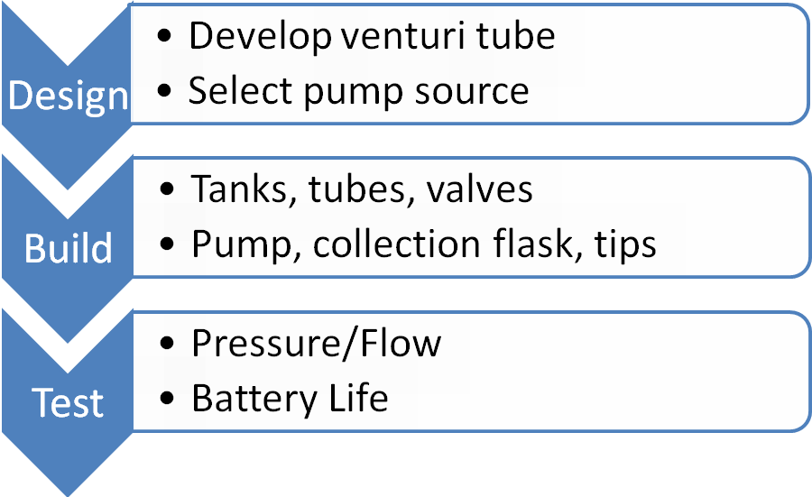

Figure 14. We have established a three-phase plan for the remainder of the semester so we can best achieve our design goals.

First, as we begin assembling the final design elements, a protocol for creation of a venturi tube from basic parts needs to be developed. Also, the required positive displacement pump needs to be located for salvaging from an existing piece of machinery, such as an automobile. Tanks, tubes, valves, and other hardware must also be selected. Then, the project will advance to prototype construction, where the prototype will be assembled and the steps recorded for conversion to an instruction manual. The instruction manual will accompany the design to allow the device to be built without direct contact with the design team. Finally, prototype testing can ensue. Tests will be performed on the prototype to determine its flow rate and pressure characteristics as well as what the estimated life of a 12 VDC car battery would be to run the device. We will summarize our construction and testing results in a user’s manual that could be used for implementing our design in a developing community.

References
“Engineering World Health.” (2008). Online. http://www.ewh.org

Marka et al. (1999). U.S. Patent No. 5,934,888. Washington, D.C.: U.S. Patent and Trademark Office.

“How a propeller works.” (2008). Online. http://www.mh-aerotools.de/airfoils/propuls4.htm

“Portable suction units.” (2008). Online. http://www.suctionunits.com/portable-suction-units.html

“Portable vacuum aspirator.” (2008). Online. http://outlet.med1online.com

Appendix

Product Design Specification (PDS)

Engineering World Health Aspirator (November 23, 2026)

Claire Flanagan - Team Leader
Adam Rieves - Communications
Michael Socie - BWIG
Justin Lundell – BSAC

Problem Statement
Most developing world hospitals do not possess operating suction machines. The main problems
are the lack of available spare parts, the cost of a replacement unit, and dependence on consistent
electricity. The objective of this project is to design and develop a medical grade aspirator that can be manufactured inexpensively from locally available materials. Along with the device, an instruction manual will be produced to allow for proper usage and care in the future.

Client Requirements:
• Device should run on 12 V batteries with manual back-up.
• Device should provide the broadest range of applications possible, with a high setting for adult applications and anesthesia and a low setting for neonatal applications and gastrointestinal work.
• Device must include autoclavable suction tips and collection flask.
• Device must be completely manufactured from locally available materials for under $100.

Design Requirements
- Physical and Operational Characteristics
- Performance requirements: 0-550 mmHg vacuum (gauge), 0-15 L/min flow of air

b. Safety: Entire device must be easily disinfected for use in a surgical setting. Aspirator tips and preferably collection flask should be autoclavable. Usage should be possible for sustained duration, preferably over eight hour intervals. Power source and motorized elements should be enclosed to minimize patient/user risk.

c. Accuracy and Reliability: Pressure and flow adjustment dials must be able to be calibrated prior to use. Device must be able to provide reliable suction throughout
an entire surgery or operation (up to 8 hours). Minimal maintenance required. Manual backup should provide reliable service.

d. Life in Service: 5 years

e. Shelf Life: 5 years

f. Operating Environment: Must be able to be stored and function under
temperatures ranging from -10 to 40 degrees Celsius and variable humidity.

g. Ergonomics: Aspirator should have minimal steps to turn on and begin use. Device, including manual back-up power and suction attachments, should be self-contained to create more space in the operating room.

h. Size: There are no specific size restrictions on the device. However, the device will be
implemented in the operating room and therefore should take up as little floor space as possible to avoid interfering with the medical staff’s ability to navigate the room. A taller device is preferable to a device with a wide base. Collection flask should be approximately 1-3 L.

i. Weight: There are no specific weight restrictions on the device. For movement inside
hospital, if the device weights more than 10 kg, it should include means for movement such as wheels.

j. Materials: Completely manufactured using locally available parts.

k. Aesthetics, Appearance, and Finish: Moving parts, sharp edges, etc. need to be
shielded from clinical environment.

- Production Characteristics
- Quantity: Device should be able to be widely implemented in a third world community.

b. Target Product Cost: < $100 per device using locally available materials.

- Miscellaneous
- Standards and Specifications: Device should ideally abide by safety standards and
regulations set by the Association for the Advancement of Medical Instrumentation (AAMI) and the FDA.

- Customer: EWH-affiliated medical professionals and institutions in developing
communities. Instruction manual should be sensitive to language barriers.

c. Competition: Discarded medical aspirators from developed nations.

