Quad Rat Vitals Monitor

Client: Dr. Alex Converse
Advisor: Dr. Tom Yen

Group Members:
Jack Ho – Team Leader
Nathan Werbeckes – Communicator
Joseph Yuen – BSAC, BWIG

Mid Semester Paper for BME 402, Spring 2009
Table of Contents
Abstract 3
Background 4
Problem Statement 6
Final Design of Last Semester 8
Circuit Design 10
Current Semester’s Work 11
Signal imported into LabVIEW 11
Breathing Rate 11
Heart Rate and SpO₂ 11
Testing 13
Temperature 13
Pulse Oximeter 14
Future Work 15
Acknowledgements 17
References 18
Abstract
In the course of our client’s research, PET imaging of rats are often used. During each scan, four rats are anesthetized and manually kept under anesthesia for the course of a few hours. Because the current system of anesthesia requires manual adjustments, the vitals of each rat must be monitored constantly. Currently our client is using a veterinary pulse oximeter designed for “small animals” (such as dogs, cats, and monkeys). However, since the rat has a relatively much higher heart rate, the machine often displays inconsistent readings, greatly reducing the efficiency of anesthesia delivery. Our novel monitoring device allows for the record and display of SpO2 levels, heart rates, and body temperatures of four rats simultaneously during PET imaging experiments in order to maintain appropriate anesthesia dosages on each of the four rats independently. Design and construction of this device are underway and currently, the device is still being constructed and tested, but will be able to, simultaneously on four rats, accurately detect heart rates up to 500 bpm and blood oxygen saturation levels with an accuracy of ±2% so that the anesthesiologist is able to determine the adequate dosage of isoflourine to keep the rats anesthetized. The device will also be able to monitor and record rectal temperature (93-100° F) and respiratory rate (around 20 breaths/min). The thermometer portion of the device has already been successfully completed and awaits animal testing.

Background
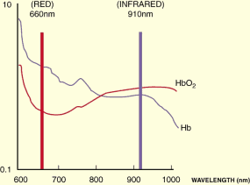
A pulse oximeter can be used to determine the SpO2 and heart rate non-invasively. It consists of a pair of red and infrared LEDs, which has wavelength at 660 and 940 nm respectively. These LEDs face a translucent part of the body, such as the earlobe or fingertip, and on the other side there is a photodiode, which produces current depending on how much light reaches the photodiode. Absorption at wavelengths corresponding to red (660 nm) and infrared (940 nm) differs significantly between oxyhemoglobin and its deoxygenated form, therefore from the ratio of the absorption of the red and infrared light the oxy/deoxyhemoglobin ratio can be calculated (Webster, 1997).
Figure 1. Difference of absorption at different wavelength (http://www.oximetry.org/pulseox/principles.htm)
After the transmitted red (R) and infrared (IR) signals pass through the measuring site and are received at the photodetector, the R/IR ratio is calculated.

From Beers law, I=Ioe^{-αct} , where I is the amount of light detected by the photodiode. R/IR ratio = ln(IMaxRed/IMinRed) / ln(IMaxInfraRed/IMinInfraRed)
The R/IR is compared to a "look-up" table (made up of empirical formulas) that convert the ratio to a SpO₂ value. Typically a R/IR ratio of 0.5 equates to approximately 100% SpO₂, a ratio of 1.0 to approximately 82% SpO₂, while a ratio of 2.0 equates to 0% SpO₂ (Webster, 1997).
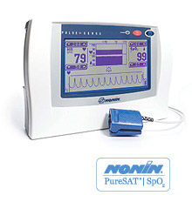
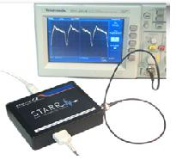
Companies such as Nonin, Nellcore produce pulse oximeter currently in the market. However, they are mostly for humans. There are also some veterinary oximeters in the market. However they are not suitable for use with mouse. Mouse has an average pulse rate of 300 beat per min, which is more than threefold of what human would have had. Our client is currently using pulse oximeter designed for humans on mice, and the pulse rate shown on the device is always out of the usual range of mice. The reason is due to the algorithm of signal processing as there is less blood passing through the artery with each beat, comparing to human. Currently there is a pulse oximeter specialized for mouse, named MouseOx, which is produced by Starr Life Science, however the cost for this device is estimated to be more than $7,000 USD.
Figure 2. PulseSense™ portable oximeter by Nonin.
Figure 3. MouseOx™ by Starr Life Sciences.
Heartrate can also be detected because the arterial blood vessels expand and contract with each heartbeat. This is shown on the waveform of the pulse oximeter. By measuring the time distance between two consecutive peaks, we can calculate the pulse rate by 1/time.
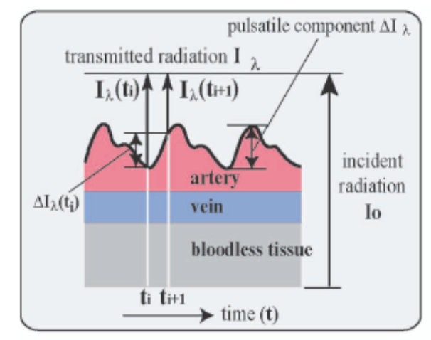
Figure 4. Normal waveform obtained by a pulse oximeter. Heart rate can be determined by the distance between two peaks (Yamakoshi 2006).

Problem Statement
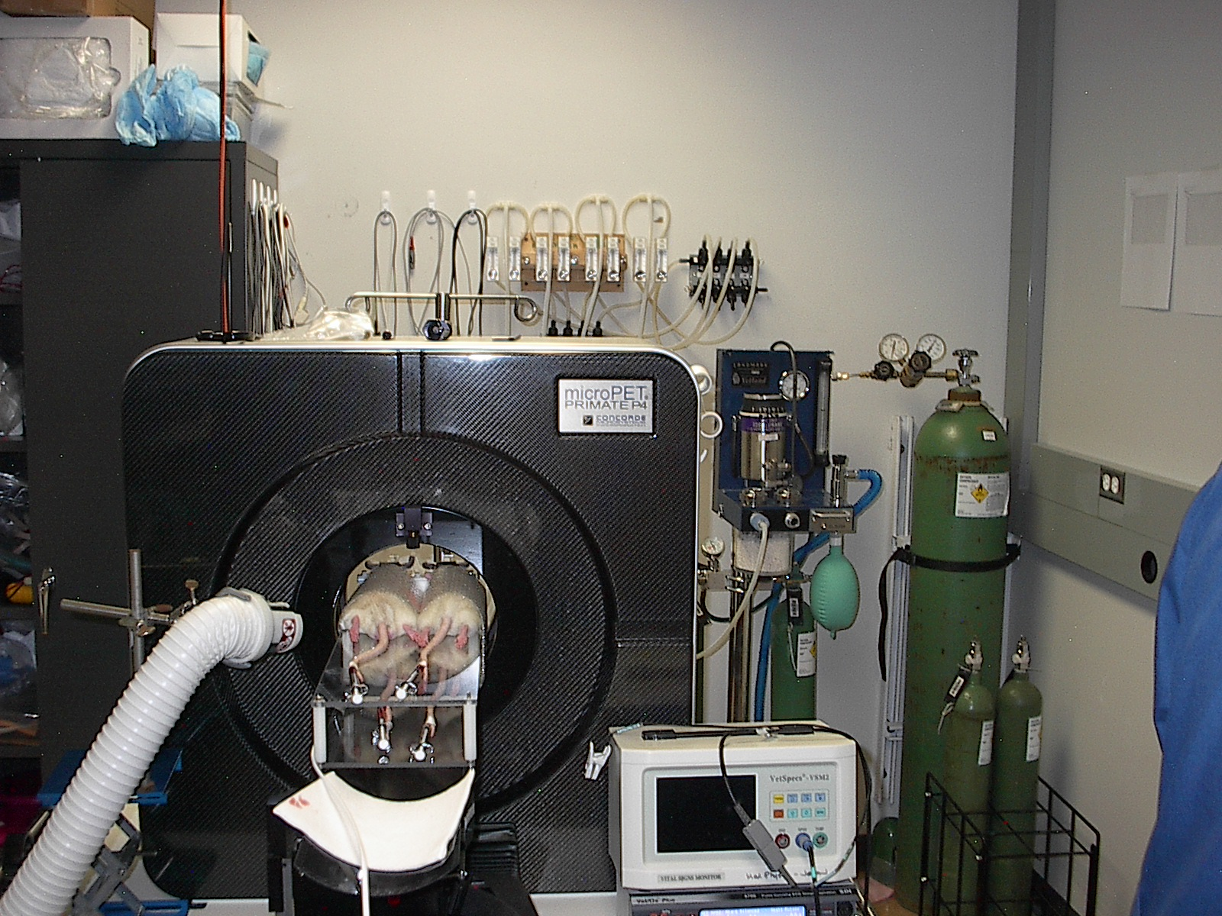
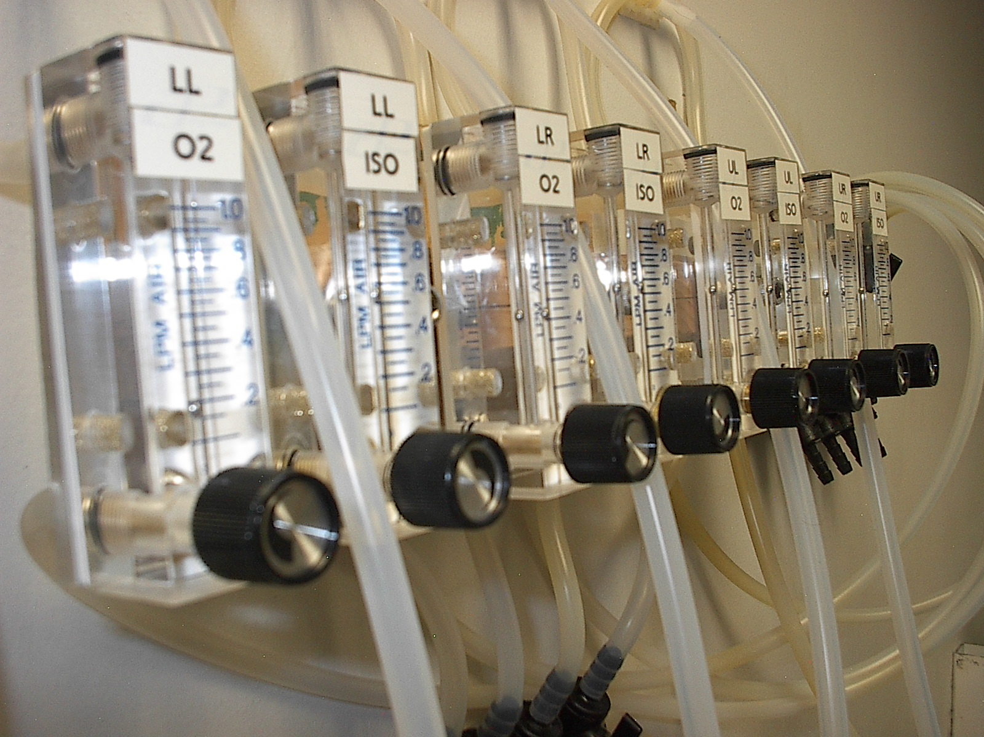
In the course of our client’s research, PET imaging of rats are often used. During each scan, four rats are anesthetized and manually kept under anesthesia for the course of a few hours. Because the current system of anesthesia requires manual adjustments, the vitals of each rat must be monitored constantly. Currently our client is using a veterinary pulse oximeter designed for “small animals” (such as dogs, cats, and monkeys). However, since the rat has a relatively much higher heart rate, the machine often displays inconsistent readings, greatly reducing the efficiency of anesthesia delivery. Our novel monitoring device allows for the record and display of SpO₂ levels, heart rates, and body temperatures of four rats simultaneously during PET imaging experiments in order to maintain appropriate anesthesia dosages on each of the four rats independently. The device will need to be able to, simultaneously on four rats, accurately detect heart rates up to 500 bpm and blood oxygen saturation levels with an accuracy of ±2% so that the anesthesiologist is able to determine the adequate dosage of isoflourine to keep the rats anesthetized. In addition to monitoring the heart rate and SpO₂ levels, our client would also like us to design the device to be able to monitor and record rectal temperature (93-100° F) and respiratory rate (around 20 breaths/min). If the device is able to effectively monitor the rats at the set specifications (up to 500 bpm, ±2% SpO₂, 93-100° F, and detect breathing at around 20 breaths/min), we hope to implement a computer controller to automate the anesthesia delivery system.
Figure 5. This picture shows the current set up of our client’s PET imaging machine. Four rats are placed into the machine, two rats stacked on top of the other two. The pulse oximeter out client is currently using to monitor heart rate and SpO₂ levels is to the right of the PET machine.
Figure 6. Isoflurane delivery system. Knobs are manually adjusted by an operator to mix appropriate amounts of isoflurane and oxygen in administering the proper concentration of anesthesia.

Last Semester’s Idea

An idea we considered was reverse engineering the cheaper parts of the system and replacing the more expensive components. We would begin with a human oximeter sensor. We would adapt this so that it would be able to fit on a rat paw. We would also take apart the cord and find out what signal is being sent in each wire so that we use those voltages as inputs. We would take the voltages and feed them into a data acquisition box, which would send that data to a LabVIEW program where they would be analyzed and displayed through a LV GUI.
In place of that thousands of dollar box, we will get a simple DaQ and use LabVIEW to process the signals. This cost is well within our budget. The construction is not much more complicated either, but will involve redoing the actual sensor to fit with a rat. This will take a lot more planning and reverse engineering of the output signals. This idea can easily incorporate additional rats or other measurement devices by simply plugging their inputs into our DaQ.
Final Design of Last Semester
LabVIEW

In our revised final design the sensor outputs are fed through the circuits described above and are then recorded using a data acquisition box which sends the analog channels voltage data to LabVIEW. The first step in the LabVIEW coding is to reset the DaQ device and record the initial time in an array. Once the DaQ has been reset it can start recording data. Currently, the data is recorded in two different ways. First, the data is recorded as a waveform and this data is easy to graph and is therefore used to display the information on the front panel. We would like to be able to use this form of data for all the needed calculations, but it is not being stored properly. Right now, the waveform is only holding a single point of data in it. Therefore, it is not possible to see if the data is increasing, decreasing, or if it has just passed a certain threshold. Next semester we hope to find out why the data is being transferred in the way you would expect.
The second way the data is recorded is as a single point. This single point is added to an array of all the previous points. The program then is then told how many seconds to use for a moving average (this is currently manual, but will be internal to the program after some testing for best results). It then adds up all the points in the array that correspond to the designated amount of time and divides by how many points there are. In this way it computes a moving average.
In the next step, the program checks to see if the voltage has just surpassed this average. The most current value of the array is compared to the moving average. If the current value is above the moving average and the data point directly before the current point is below the moving average the data has just spiked above average. The program then records exactly what time this event occurred at.
Whenever a new time point is added a new bpm is computed. This time the program is told to count back a certain number of pulses—that is currently inputted manually (that will be internalized after more testing)--and takes all of these pulses and measures the time between each one. These data are added together and divided to find the average length of time between pulses. This number is in milliseconds, which is then converted to a bpm with simple arithmetic. This heart rate is then displayed on the front panel.
Circuit Design
Because of the use of light in the absorbance measurement, we need a "light-to-voltage" conversion using current as the input signal. The classes of photodiode amplifiers suitable for pulse oximetry applications are the classical resistor-feedback transimpedance amplifier and the capacitor-feedback switched integrator. This circuit is also common in use with piezoelectric sensor, which also gives out a small current with respond to stimulus. This is the first stage of our circuit (Figure 7).
In the pulse oximeter case, the light shining on a photodiode produces a small current that runs to the amplifier-summing junction and through the feedback resistor. Given the very large feedback resistor value we used (4.7 MΩ), this circuit is extremely sensitive to changes in light intensity. A small capacitor (390 pF) is used to control gain peaking caused by the diode capacitance.
The second stage of the circuit is a differential amplifier, which is used to filter out the common noise from the input. The third stage is a non-inverting amplifier with a gain of 22 so the output signal can be observed on the oscilloscope. 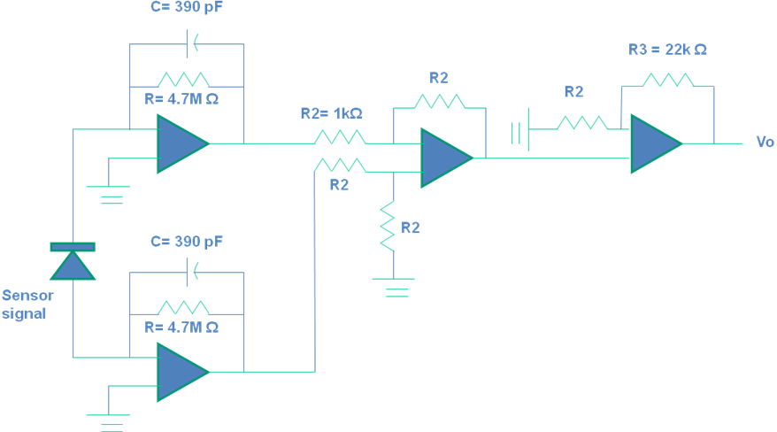
Figure 7. Circuit diagram for the pulse oximeter.
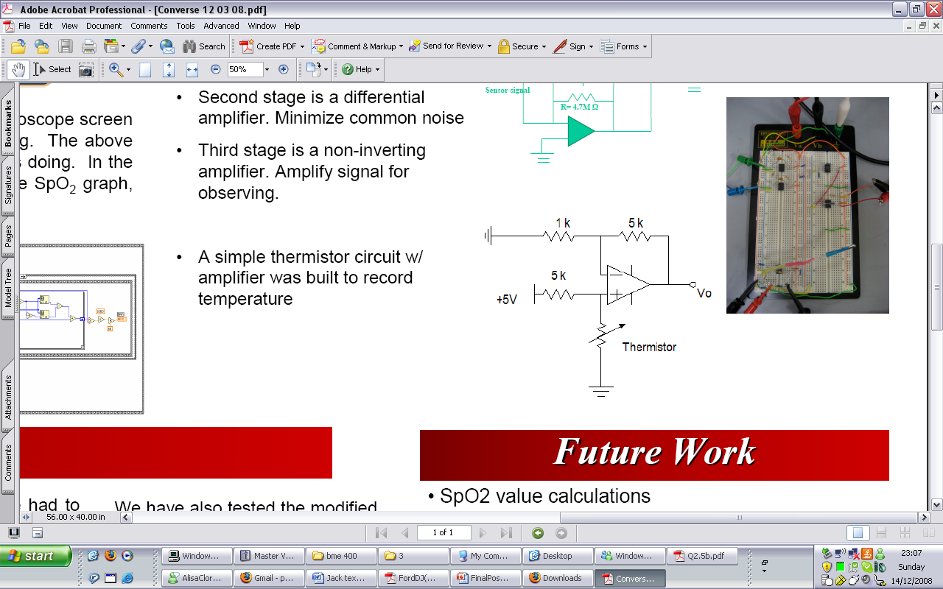
Figure 8. Circuit diagram for the thermistor.
For the thermistor circuit (Figure 8), we use a non-inverting amplifier to get the signal. We place the thermistor at the positive input at the op-amp. When the temperature causes resistance to change, the voltage across the thermistor changes. This voltage is then amplified by the resistor pair, which has a gain of +5.
Current Semester’s Work
Signal imported to LabVIEW
The biggest short coming of last semester was that we were unable to aquire the output signal of our pulse oximeter sensor and import it into LabVIEW. After adjusting numerous settings on both the DAq box and LabVIEW itself, we were finally able to import the signal into LabVIEW and do some signal processing.
Breathing Rate
This semester we designed for the ability of our device to monitor breathing rate. Initially we came up with three different methods on how we could acquire a signal corresponding to breathing rate.
Design 1: Strain gauge
Our first idea is to mount a foil strain gauge to some elastic band which can wrap around the abdomen of the rat. When the rat breathes, its abdomen expands and contracts, so the circumference of the abdomen would change. This change can stretch the strain gauge which is wrapped around the rat, increasing the tension experienced by the strain gauge. As a result, for every breath, there will be a change in tension, which gives us the breathing rate. However, strain gauge needed to be calibrated before use. Also, it might not attach to the abdomen even though there is an elastic band wrapped around it.
Design 2: Pressure transducer
Our second idea is use a pressure transducer, similarly used in the cuff used for taking blood pressure. We can design a cuff to wrap around the rat, and then inflate the cuff. When the rat breathes, its abdomen expands and contracts; since the cuff is wrapped tightly around the rat, the pressure transducer outside the cuff can then sense the change in pressure inside the cuff caused by respiration. From the pattern of change we can determine the respiration rate. Alternatively, we can add an inflated balloon between the cuff and the rat, and measure the change of pressure of the balloon during breathing and get the respiration rate. The advantage of this method is that the pressure transducer need not be in the cuff. It can be connected to the cuff with a tube and still get nice results. However, a pressure transducer is expensive and also, it might not be accurate if the balloon was placed in somewhere on the abdomen which has limited movement.
Design 3: Force Sensing Resistor *(chosen design)
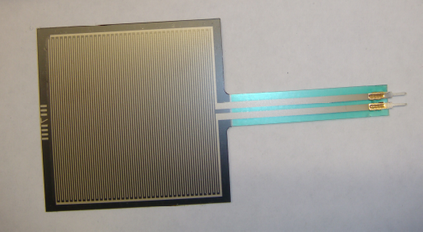
Our third design, the design we finally chose, is using a force sensing resistor (Figure 9) to measure the force exerted to the sensor when the rat breaths. In this case, the resistor is placed right beneath the abdomen of the rat. When the abdomen expands, it exerts force to the resistor and the resistance changes. Applying a simple voltage divider would allow us to get the fluctuation in resistance in terms of voltage. From the pattern, we can then calculate the breathing rate. The advantage for this design is no complicated circuit is needed as in design 2 and 3, also the resistor is always fixed in place (beneath the abdomen), and it is relatively much cheaper.
Figure 9. Force Sensing Resistor (FSR)

Heart Rate and SpO₂ with Red and Infrared Waveforms
We need to have two waveforms, one Red and one infrared, to calculate the SpO₂. Usually in a commercial unit, the red LED and IR LED turns on and off alternatively, with timing circuit built in, so we can get two waveforms and find the ratio between the peak and the baseline and then compare it to a table and get the SpO₂ value. However, originally, we only got one waveform, and that was not sufficient to find SpO₂. As we have been solely using positive DC as our LED source, we guessed that if reversed the polarity and a negative DC source was sent in, we could turn on the infrared LED. It had been tested that when a negative DC signal was feed to the LED, we still got a very nice and clean signal just as when we fed in a positive signal, only a difference in magnitude, which proved our assumption was right.

To find SpO₂, we need to determine when the red LED is on and measure it. Alternatively, determine when IR is on and measure that, and take corresponding readings. That is why the signal polarity frequency needs to be carefully considered. But since our output is still from one channel (having only one photodiode), we have to split it into two sets of data, correspond to the polarity of the input signal. This might be done in LabVIEW. The timing pattern was suggested 480 Hz in Prof. Webster’s book (Webster, 1997).
The heart rate of human is around 1 Hz. Assuming that the heart rate is at 1 Hz and the timing pattern is 2Hz. Then for every second, the first 0.5 sec is under RED and second 0.5 sec is under IR. What this means is that the RED data we get is always the first half part of the heartbeat, and IR LED always shines during the second half. Since the highest value of the waveform only appears in the first part and the lowest value only appears during the 2nd part, we never get the appropriate Rhigh / Rlow ratio or IRhigh/ IR low ratio. So a high timing pattern might be the key to get an accurate result.
Rats have a heart rate of around 300-400bpm. Which means the frequency is around 6-7 Hz. Assume it is 6 Hz, which was 6 times higher than human. If the timing pattern is already 480 Hz for human, then we believe that for a rat, the pattern should be much higher in order to capture the right data point. That might be the reason our client is getting a fluctuating and unrealistic low SPO2 value, because the rate is not high enough to capture the correct data point.
Due to the complexity of being able to acquire both waveforms and process them to get the blood oxygen saturation along with the timeframe of this project, the priority has been set to complete the other components of our device to be fully functioning before we move onto acquiring the SpO₂ levels.

Testing (Last Semester)
Temperature
The design of the thermistor was tested using a thermometer as a reference. Based on the specification (accurately measuring a temperature range between 93-100 °F), the thermistor and the thermometer were placed in water. The water was then heated to above 105°F and slowly cooled to 90°F. During this process, an analog voltage signal was recorded with measurements from the thermometer. This procedure was repeated twice to ensure accuracy of the thermistor. Data was plotted measuring the analog voltage output versus temperature (Figure 10). A linear function was chosen to calculate the relationship between output voltage and temperature because the thermistor displayed linear performance through this temperature region. The first trial showed an R square value of 0.975, while the second trial yielded an R square value of 0.988. Both R square values are quite high, and repetition of the procedure further improved the R square value (showing increased skill in performing this procedure).
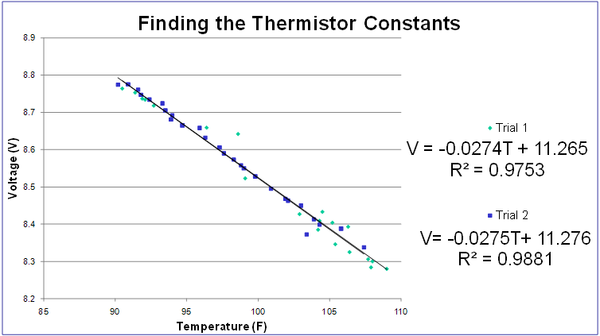
Figure 10. Voltage vs. Temperature. After testing of the thermistor, we found that within our design specification range (~90-110 ˚F) the correlation between temperature and output voltage was very near linear with a R² greater than 0.975.

Pulse Oximeter
The modified pulse oximeter with the circuit discussed in the final design demonstrated a clear output analog signal (Figure 11). Each heart beat created two peaks (first a larger peak followed by a smaller peak), and the signal was successfully compared by placing existing pulse oximeter on the same finger on the opposite hand. These two peaks may represent the red and infrared transmission detected by photodiodes and will allow us to calculate the SpO₂ levels from an algorithm.

Future work
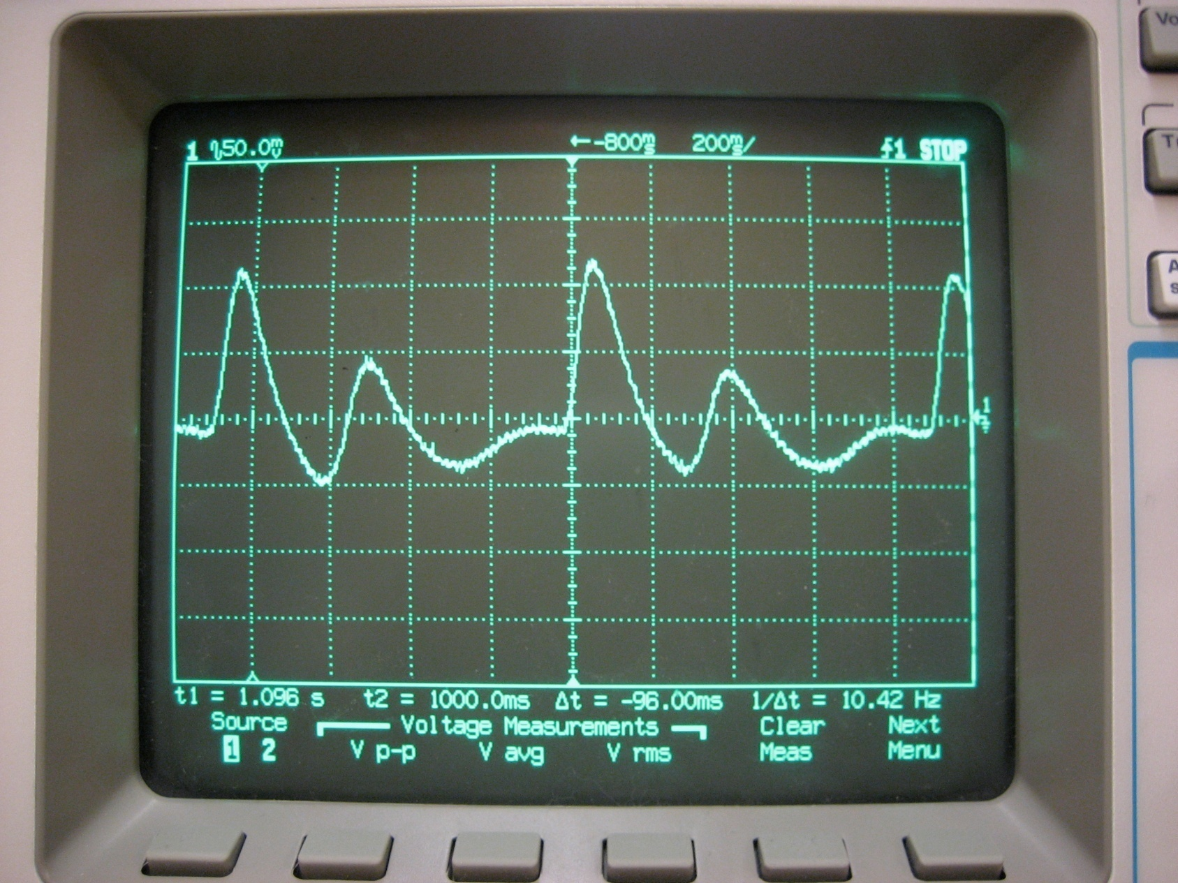
Currently, the priority is to being testing the device on rats. We need to test the FSR component to observe whether or not it can function properly, and if it does, properly calibrate the signal. Now that we can acquire the signal and input it into LabVIEW, we need to test the pulse oximeter sensor on the anesthetized rats in order to obtain the rat’s plethysmographic waveform. Once we have the waveform, we can design the heart rate detecting algorithm based on the shape of the waveform. It will also let us know whether or not we will need to amplify the signal, since the device is currently only known to work on humans.
Figure 11. Oscilloscope screen shot. Shows the clean signal obtained from our pulse oximeter circuit. We believe the two peaks are red and infrared transmission of each pulse.
Once the components of our design have been tested, appropriately calibrated, and our circuitry is set, we will design and purchase a printed circuit board and assemble all the components of our circuit. We plan to find a suitable power source, attached it, and make it as mobile as the laptop containing the LabVIEW software.
Finally, a completed fully functioning prototype will be tested on the rats and the results will be analyzed. It is important to make final adjustments, such as modification of user interface (e.g. GUI representation and placement of each components of display [Figure 12]). If there are further inquiries or comments, please contact us at RatMonitor@gmail.com.

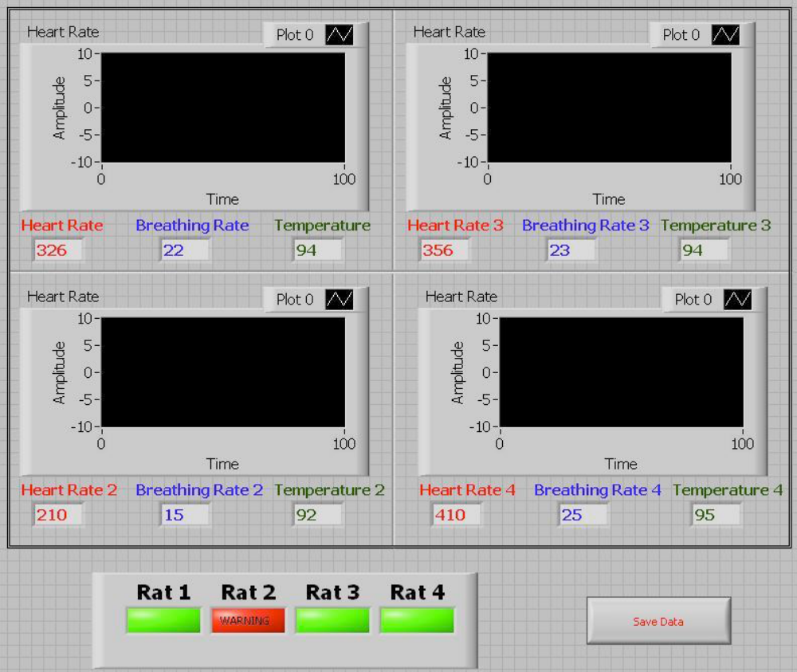
Figure 12. Design of user interface. Graphs are used to display the plethysmographic waveforms of each rat. Heart rate, breathing rate, and temperature will be shown numerically underneath. Warning lights will also be placed underneath alerting the user if a rat has fallen into dangerous conditions.

Acknowledgement
Thank you to all of those who contributed, especially Professor Thomas Yen, PhD, Client Alex Converse, PhD, Amit Nimunkar for their support and assistance, we would also like to thank Sharing Resources Worldwide for providing us with sensors and equipment, without them this project would not have been possible.
References

Ford D., D. Nachreiner, R. Thomas (2005), “Design of a Pulse Oximeter for Use in Mice”.

K. Yamakoshi and Y. Yamakoshi (2006). Pulse glucometry: a new approach for noninvasive blood glucose measurement using instantaneous differential near-infrared spectrophotometry. Biomed. Opt., Vol. 11, 054028 ; DOI:10.1117/1.2360919

Starr Life Sciences (2008). MouseOx. From http://starrlifesciences.com.

Webster, J. G. (1997), Design of Pulse Oximeters. IOP Publishing Ltd.

