University of Wisconsin – Madison
Department of Biomedical Engineering
BME 200/300 – Design

MRI Gradient Coils
Mid-Semester Report
Neal Haas - BSAC
Peter Kleinschmidt – Leader
Anne Loevinger - Communicator
Luisa Meyer - BWIG

10/20/2008

Contents
Table of Figures 2
Abstract 3
Problem Motivation 3
Background 5
Design Specifications 6
Common Coil Designs 7
Product Development 8
Simulation 9
Validation of Computations 10
Future Work 11
References 12
Appendix A – Product Design Specifications 13
Appendix B – Biot-Savart Script 15

Table of Figures

Figure 1 – Coordinate system for the MRI 1
Figure 2 – The Helmholtz Coil Pair 1
Figure 3 – The Magnetic Field Created by Helmholtz Coil Pair 1
Figure 4 – The Maxwell Coil Pair and Direction of Current Flow 1
Figure 5 – The Golay Coil Pairs 1
Figure 6 – Preliminary Design concept for probe stand. 1
Figure 7 – Final design of Probe stand. 1

Abstract
As part of a broader goal to develop novel applications of Magnetic Resonance Imaging (MRI), a low-cost and modular MRI system is currently being developed. One component of this project is the design, construction and testing of gradient coils to function within the system. In addition to background on MRI, several common gradient coil designs are presented within this report, and serve as a basis for development. A simulation script has been developed to approximate magnetic field strengths produced by a given coil design. This will aid in formulating a coil design that produces a magnetic field that varies linearly along its axis. Finally, designs for a testing environment have been developed to aid in the design of the coils, as well as to validate the simulations. Future work will include construction of the testing apparatuses, validation of the simulation script, and preliminary construction and testing of one set of gradient coils.

Problem Motivation
Magnetic Resonance Imaging (MRI) is a non-invasive medical imaging technique that creates cross-sectional images of the body. It mainly functions as a tool to help physicians diagnose medical conditions. By taking advantage of the nuclear spin inherent in protons and influencing them with a powerful magnetic field, MRIs can align the magnetic poles of all protons in a specimen. After alignment, it creates images with the aid of radiofrequency amplifiers, data acquisition units, and computers. Additionally, MRIs use gradient coils as a way to distinguish points in three-space.
A complete Magnetic Resonance Imaging system cannot always provide medical professionals with the detailed, potentially life-saving information that they desire. It would be most advantageous to be able to use Magnetic Resonance (MR) technology to address more specific problems in the medical field. For example, it would be useful to be able to image heart chambers or other vital parts of the body in real time and from multiple angles, all with a greater image quality than provided by a traditional MRI system.

In order to accomplish this goal, MRI probe designs have been developed. The goal for the probes is to be able to use them for MR guidance. These probes, when used, would be guided to the specific point of interest on a patient and then oriented to a satisfactory position where the doctor could proceed with the imaging. This method would also be easier on a patient since unlike in a full MRI system, multiple images would not require the patient to be repositioned multiple times. Theoretically, the probes would produce a better, more useful image to doctors. It has been implied by the clients that the primary use for the probes would be to observe parts of the circulatory system, particularly heart chambers.

Before being able to implement the probes in any kind of medical setting, they need to be validated in some fashion. One option for validation involves testing the reliability of the probes using a large MRI system. This method of testing introduces a series of complications. Since the MRI system is a very valuable piece of technology, it is very expensive with the average price of a new system being upwards of $1.0 million. If anything malfunctioned during testing and caused damage to the equipment it would be quite pricey to repair. Also, it would be difficult to conduct probe testing on an MRI system since it is not portable and would therefore be very inconvenient for researchers to use. In addition, it is not cost or time effective for researchers to use the system for testing purposes when it is almost always in use for other medical functions. Some alternative methods have been proposed to address these complications.

It is believed that the easiest and most cost-effective method for validating the probes would be by using a desktop MRI testing unit. This unit would be less expensive and able to perform all of the needed functions to test the probe designs. It would be considerably more convenient for the researchers also, as the system would be housed in one of the research labs. The unit, although smaller, would still require a static magnetic field and gradient coils similar to a clinical MRI system. To accomplish this, the researchers have already begun to develop a Radio Frequency (RF) Stimulator, however this is only one of many steps in the development of the system. The desktop system would need to have a different gradient coil configuration than the traditional MRI apparatus because of size and because of the permanent magnet that will be used for the static field.

The goal for the semester is to develop a set of gradient coils for the aforementioned desktop MRI system. The system will be cylindrical with the poles of the permanent magnet fixed at opposite walls of the tube. Although an MRI system encompasses three gradients in the x, y, and z directions, the work done on the project will be focused solely on the coils that control the z-gradient, which is the gradient in the plane of the permanent magnet. The coils will be attached along the side of the walls of the cylinder, same as the magnet. Designs of commonly used coil types, computerized simulations and electromagnetic principles will be used to validate the new designs.

Before bending metal and performing calculations, it is first necessary to design a simulation and testing environment. This environment will allow for the distinguishing of valid assumptions and ideas. The testing area will provide a way to measure magnetic field and compare theoretical results acquired using mathematical methods with results obtained experimentally. Although building the testing environment is important in the design process, it is not the ultimate goal. The hope is to have a design for the z-gradient coils by the conclusion of the semester.

Background
The theory behind MR technology lies in what is called Nuclear Magnetic Resonance (NMR). It refers to the quantum mechanical phenomenon where all atoms with unpaired protons or neutrons have a magnetic moment. This moment is derived from a non-zero “spin”. Spin is a concept which delves into more complicated quantum theory beyond the scope of this report. A proton (¹H) is the most abundant of these isotopes that have a non-zero spin and exists in water, which occupies nearly every portion a person’s body. As a result, MR imaging techniques can give very detailed image slices of virtually any portion of the human body without ever making an incision or exposing it to harmful radiation. However, the ¹H atoms themselves cannot be read to create an image. Rather, they are aligned using a powerful magnet and then disturbed with radio waves.
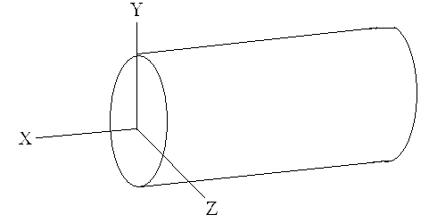
The main magnetic field, B₀, in a clinical MRI typically has a power of either 1.5T (Tesla) or 3T depending on the customer’s needs. To get a sense of the magnitude of these fields, 1.5T is about 50,000 times stronger than the Earth’s magnetic field. As a result, all ferromagnetic material must be kept away from the MRI system while it is being used. Typically, the main field is generated by two Helmholtz coils and runs parallel to the longitudinal axis of the bore. Often, the longitudinal axis is referred to as the z-axis with the x-axis and y-axis pointing in a horizontal or vertical direction. It should be noted that the z-axis points in the direction of the main magnetic field. In the system being developed, the main field points across the bore and so the x-axis is parallel to the axis of the bore. (Figure 1)
Figure 1 – Coordinate system for the MRI
The Radio Frequency (RF) amplifier supplies another magnetic field, B₁, which is perpendicular to the main magnetic field. RF waves oscillate at a specific frequency, called the Lamour frequency ω₀, and can be as large as 10T for clinical MRIs. The Lamour frequency is linearly related to the magnitude of the main magnetic field. Short pulses of radio waves push the protons out of alignment with the main field. As poles of the proton spin and realign with the main magnetic field, they emit other radio waves which are picked up by the same RF coil and the data acquisition unit.
Gradient coils are placed in several locations around the bore and create linearly varied magnetic fields in the axial directions across the imaging volume. They create gradients in the x-, y-, and z-directions, which allow the MRI to spatially encode the data. Gradient coils can have many shapes depending on the size of the bore, the amplifier being used, and the direction for which the gradient is being made. Two key qualities for gradient coils are gradient strength and slew rate. The gradient strength is measured as the change of field strength over a distance and is directly proportional to the current supplied to the coil. Its units are given as milliTesla per meter (mT/m) or Gauss per cm. The slew rate refers to how quickly the gradient coils can be turned on or off. It depends on the inductance, or geometry, of the coil as well as the quality of the voltage amplifier. Slew rates affect both the speed at which the body can be imaged and the quality of the image itself. For clinical MRIs, gradient strengths are about 2.0 mT/m/A and slew rates are about 100-200 T/s.

Design Specifications
As stated above, a modular MRI system is needed that is low cost, simple and small in size but still functional. The gradients developed for this system must exhibit a high degree of linearity in the magnetic field produced. The system will operate in a similar environment to clinical MRI systems, but on a smaller scale. Rather than a powerful superconducting magnet, a permanent magnet will be used to establish the stationary magnetic field, though the field strength has not yet been specified. Typical pulse durations range from 0.008 – 11 milliseconds, which is determined by several factors, including the amplifier used and the inductance of the coils. These factors will be specified as the system is developed further. Initially, the gradient coils will run on direct current (DC), although the system could be modified to operate with alternating current (AC) in the future.

The MRI system will have a bore that includes two concentric cylinders. The permanent magnet will be on the outer cylinder, and the gradient coils will be wrapped around the inner cylinder. For this system, the inner diameter of the coils will be approximately 12 inches. The gradient coils will be made from copper wire; the gauge will be determined by design characteristics and the results of testing trials. The magnetic field generated by the coils will be measured with a Hall Effect Probe. The coils will be designed to optimize the linearity of the field generated.

The fully functional system should cost less than $10,000 to produce, ideally within the range of $3,000-5,000. At this time, only one unit will be produced. Since the system is intended for experimental use, it does not require FDA approval. As no human subjects will be used at this time, IRB approval is not needed. In the future, design modifications may be needed to make it safe for patient testing. Research has been done in the field to simplify clinical systems to a modular interface. This is similar to goals of the project, but still integrates expensive clinical systems (Stang, et al., 2008).

Common Coil Designs
A number of different designs that are commonly used by MRI systems will be considered in the development of the gradient coils. Several are outlined below.

The Helmholtz coil pair is the most simple coil design we are considering (Figure 2). As pictured below, the design includes a pair of circular coils having the same radius and a common central axis. When current is applied to generate the magnetic field, the current flows the same direction through both coils, (i.e. the current flow is parallel through both coils). This creates a magnetic field that is fairly uniform (Figure 3). The strength of the magnetic field is easily calculated based on the current applied. Though useful for creating static magnetic fields, these coils do not produce a gradient.
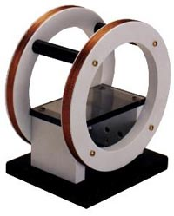
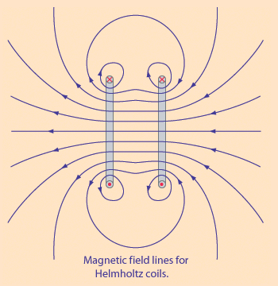

Figure 2 – The Magnetic Field Created by Helmholtz Coil Pair
http://hyperphysics.phy-astr.gsu.edu/hbase/magnetic/helmholtz.html

Figure 3 – The Helmholtz Coil Pair
www.oersted.com/helmholtz_coils_1.shtml

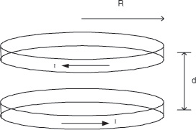
The Maxwell coil pair is very similar to the Helmholtz coil pair. In Maxwell coils, current flows in opposite directions through the two coils (Figure 4). The magnetic field created between the coil pair is graded. The Helmholtz coil is commonly used for the z-axis of the MRI gradient field. Linearity is achieved with the choice of the sizes of radius (R) and distance between the coils (d). However, using only two coils, the linearity of the gradient is limited.
Figure 4 – The Maxwell Coil Pair and Direction of Current Flow
http://physics-nmr.la.asu.edu/probes/hightemp/Images/maxwellpair.jpg

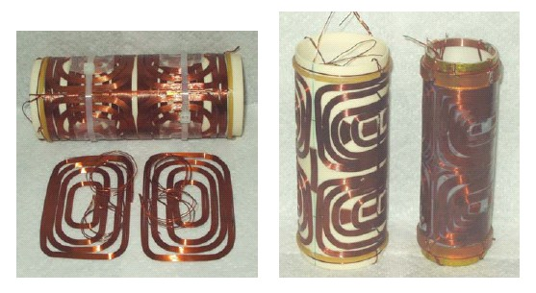
Golay coils are a type of saddle coil (Figure 5). The benefit of using Golay coils in MRI systems is that they are designed to be formed about a cylinder. The uniformity of the magnetic field produced can be varied based on the radius of the coils and the axial locations of the coil pairs. However, calculating the magnetic field is much more difficult for the Golay coils than the calculations for the Helmholtz and Maxwell coils. Golay coils are a common design for generating gradient fields along the x and y axes of clinical systems.
Figure 5 – The Golay Coil Pairs
www.dotynmr.com/mri/mri_fcgcpg.htm

These different coiling designs provide a starting point for development of coils to function within the system in development.

Product Development
Development of the design for the winding of the coils requires simulation and modeling for optimization to determine optimal winding patterns. In order to achieve this, a method of simulation is needed. Additionally, a verification method is needed to test the validity of the simulation results in rudimentary settings and, eventually, the final design of the coils. Each of these requirements demands substantial development considerations. The progress on their development is outlined in the sections below.

Simulation
Several options are available for the simulation of magnetic field strengths induced by current running through the gradient coils. Magnetic field strength and direction are determined by the Biot-Savart Law, defined as:
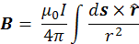

Where B is the magnetic field, s is the vector along which the current flows, and r is the distance from any given point of evaluation to the current on ds. When evaluating shapes with a high degree of symmetry about their central axis, this formula is often symbolically solvable. However, when evaluating at a point off of the central axis, the solution becomes significantly more difficult, if not impossible, to find symbolically. However, a numerical approximation can be found with the application of computational software packages.

One commercially available product that can perform simulations is ANSYS (Ansys, Inc.). Preliminary work has been done with ANSYS, attempting to familiarize with the product. The software package is quite versatile and potentially useful. However, it also requires a significant amount of training to achieve adequate results. Indeed, the abilities of ANSYS may exceed the needs of this project, at least in these early development stages. With that in mind, continued work on learning the software has been pursued. In order to fulfill the more immediate need of a simple magnetic field simulation, another tool is being developed concurrently.

Given the nature of the Biot-Savart Law, with a little manipulation it presents itself to fairly simple numerical computation within an environment such as MATLAB. A code has been written which computes the magnetic field of any given coiling pattern at user defined point of analysis. The entire script is contained in the Appendix B. The code functions on the following strategy:

- Prompt for a value of current (I)
- Develop vectors for coordinates of coiling, entered as time-parametric equations
- Determine size of steps, number of pieces to evaluate numerically
- Input coordinates at which to evaluate
- Compute r and s vectors
- Run Biot-Savart equation at each point and compute the sum
- Display B vector and plot

Further development on the script will make it easier to enter more complicated coiling patterns. For example, the Golay coils discussed above are not well modeled by one parametric equation and would require multiple piece-wise inputs. Another feature which will be implemented is to calculate the magnetic field at many points within the area of analysis. This will give a better description of how the field behaves spatially. Although such computation will increase the calculation time significantly, it will be much more useful in assessing coil functionality. Ultimately, an optimization algorithm should be developed. This is a long term goal, and may extend beyond the scope of this semester.

Validation of Computations
As stated, the other main component of developing the system is validating that it functions as expected. Inaccuracies and external disturbances may affect the performance of the fields generated in practice. Thus, a method to physically observe the fields and validate them against the theoretical values is necessary. This must first be done on a simplified level to validate the numerical calculations of the custom script. With further development of the product, the performance will also need to be validated.
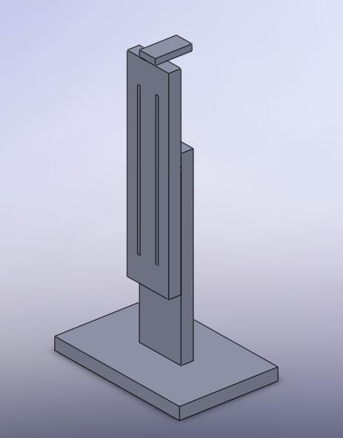
Magnetic fields are commonly measured via the Hall Effect, which can be accomplished with a Hall Probe and Gauss Meter. Both of these tools are available; however, the experimental environment for their application must be customized to the needs of this project. Since the coils will be fixed into a form, a method of positioning the probe at different locations within a three-dimensional coordinate system is needed. More plainly, a stand with accurate measurement of the location of a hall probe within three dimensions must be developed. The first design concept that was formulated to achieve this goal is shown below in Figure 6.
Figure 6 – Preliminary Design concept for probe stand.
All components of the stand are to be constructed from clear acrylic.

This stand is constructed to have vertical adjustability of the probe. The base of the stand would sit on a large flat area with a coordinate system defined across its axis. Then also fixed to this large work area could be any number of coiling designs. The probe would be freely moved about the coordinate system, and also adjusted to different heights to ultimately map out the magnetic field created by coils across all three dimensions. No mechanization of the device would be involved. All movement of the probe to different coordinates would be done by hand.

As a preliminary design, this concept appears to achieve the needed goals, however it is not optimal. A modified stand design is presented in Figure 7. This stand functions on similar principles, but in addition to a vertical adjustability, a threaded rod fixed into the track by adjustable wing nuts allows for an additional degree of freedom and extension of the probe into a semi-concealed space such as the bore of a coiling tube.
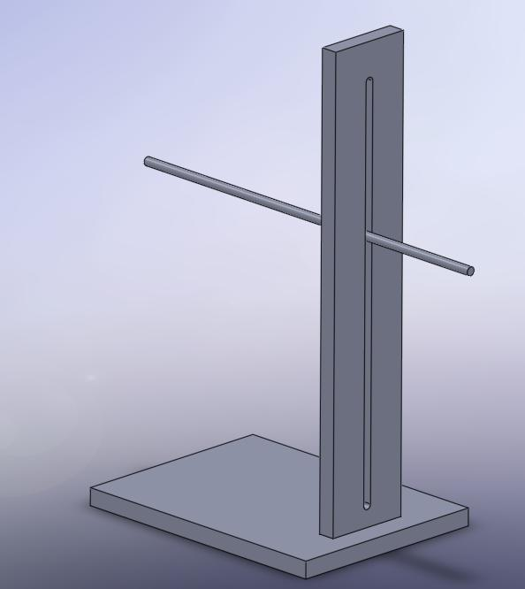
This design will provide the necessary data from magnetic fields corresponding to a three-dimensional test area. Obtaining data will be quite labor intensive since all operation will be done by hand. A mechanized coordinate adjustment system could provide more efficiency and accuracy in acquiring more data points. This may be something necessary with more finite validation. However, the scope of this project does not require more sophisticated data acquisition at this time, so this concept has not yet been addressed.
Figure 7 – Final design of Probe stand.
All components will be made from clear acrylic. The thin bar will be a 1/4” threaded rod, and will be held in place by nylon wing nuts on each side of the stand.

Future Work
In order to begin validating simulations and exploring the observed effects of various coil designs, the experimental setup must be completed. Different coil geometries will be modeled theoretically and experimentally with this setup. The data obtained will allow for refinement and optimization for a final coiling design. Ultimately, the goal of constructing one set of coils will lead to development of the two additional gradient coil sets. This gradient system will be incorporated into the modular MRI system.

References
Block, Wally. Personal Interview. September 19, 2008 and September 26, 2008.
Block, W.F., et al. (2006). Magnetic Resonance Imaging. In Encyclopedia of Medical Devices and Instrumentation (2nd ed.). John Wiley & Sons, Inc.
Enderle, John et al. “16.3 Magnetic Resonance Imaging (MRI).” Introduction to Biomedical Engineering. Ed.2.
Gould, T. “How MRI Works”. HowStuffWorks, Inc. 10 October 2008. <http://www.howstuffworks.com/mri.htm>
Kurpad, Krishna. Interview. September 19, 2008, September 26, 2008, October 3, 2008, and October 10, 2008.
Sanchez, H. et al. “3D-Gradient Coil Structures for MRI Designed Using Fuzzy Membership Functions.” Proceedings of the 29th Annual International Conference of IEEE EMBS Cite Internationale, Lyon, France, August 23-26, 2007.
Sanchez, H. et al. “A Simple Relationship for High Efficiency-Gradient Uniformity Tradeoff in Multilayer Asymmetric Gradient.” IEEE Transaction on Magnetics. Vol. 43, No. 2, February 2007.
Stang, P. et al. “A Scalable Prototype MR Console Using USB.” Proc. Intl. Soc. Mag. Reson. Med. 14 (2006). Pg. 1352.
Stang, P. et al. “Experiments in Real-Time MRI with RT-Hawk and Medusa.” Intl. Soc. Mag. Reson. Med. 16 (2008). Pg. 348.
Stang, P. et al. “MEDUSA: A Scalable MR Console for Parallel Imaging.” Intl. Soc. Mag. Reson. Med. 15 (2007). Pg. 925.
Unal, Orhan. Personal Interview. September 19, 2008 and September 26, 2008.
Zhang, Beibei et al. “Simple Design Guidelines for Short MRI Systems.” Wiley Periodicals, Inc. (2005). Pg 53-59.

Appendix A – Product Design Specifications

Low Cost and Modular Gradient System for MRI Studies
Last Modified: October 3, 2008

Team: Neal Haas (BSAC)
Peter Kleinschmidt (Leader)
Annie Loevinger (Communicator)
Luisa Meyer (BWIG)

Function:
This project is part of a larger goal to build a low-cost and modular MRI system for testing of novel multi-mode intravascular MRI probes with tracking, imaging and RF ablation capabilities. This component of the project will involve the designing, simulating, building, and testing of gradient coils to function with the system. The system will form an essential part of a low-cost MRI system.

Client Requirements:
- System needs to be low cost, simple
- Small in size but still functional
- Exhibits a high degree linearity in the magnetic field produced

Design Requirements:

- Physical and Operational Characteristics
- Operating Environment
  - Pulse Duration: .008 – 11 msec
  - Clinical Magnet Field Strength
    - 1.5 T
    - Permanent Magnet to be used: TBD
  - Amplifier Properties – TBD
    - Will use DC, could be modified to AC in the future
- Materials
  - Type of Metal: Copper Wire – Gauge determined based on design characteristics
- Size
  - Bore has two concentric cylinders
    - Magnet is on Outer Cylinder
    - Gradient Coils are wrapped around inner cylinder
  - Will be validated with Hall Effect Probe
  - Inner diameter of RF Coils (inside Permanent Magnet) = ~12 in.
- Accuracy and Reliability
  - Coils should optimize linearity of field generated
- Production Characteristics
  - Quantity
    - Only one unit will be produced at this point
  - Cost
    - Fully Functional System < $10k (ideally $3-5k)
- Miscellaneous
  - Standards and Specifications:
    - The system is intended for experimental use and as such does not require FDA approval.
    - No human subjects will be used at this time, so IRB approval is not needed.
  - Patient Related Concerns
    - The system is not currently being designed for human testing. In the future, design modifications may be needed to make it safe for patient testing
  - Competition
    - Existing products are clinical MRI machines
    - Research has been done in the field to simplify clinical systems to a modular interface. This is similar to goals of the project, but still integrate expensive clinical systems (Stang, et al., 2008)

Appendix B – Biot-Savart Script

clc

t0=input('t0=? ');
tn=input('tn=? ');
ts=input('t step size=? ');
t=[t0:ts:tn];

x=zeros(1,length(t));
y=zeros(1,length(t));
z=zeros(1,length(t));

x=input('x=? ');
y=input('y=? ');
% z=input('z=? ');
x0=input('Evaluate at point x0=? ');
y0=input('y0=? ');
z0=input('z0=? ');
I=input('I=? ');

mu=4*pi*10^(-7);
l=length(t)-1;

for n=1:l

sx(n)=x(n)-x(n+1);
sy(n)=y(n)-y(n+1);
sz(n)=z(n)-z(n+1);

rx(n)=x(n)-x0;
ry(n)=y(n)-y0;
rz(n)=z(n)-z0;

end

s_cross_r_i=sy.*rz-ry.*sz;
s_cross_r_j=-(sx.*rz-rx.*sz);
s_cross_r_k=sx.*ry-rx.*sy;

mag_r_squared=rx.^2+ry.^2+rz.^2;
scri_divrsq=s_cross_r_i./mag_r_squared;
scrj_divrsq=s_cross_r_j./mag_r_squared;
scrk_divrsq=s_cross_r_k./mag_r_squared;

i_all=transpose(scri_divrsq);
j_all=transpose(scrj_divrsq);
k_all=transpose(scrk_divrsq);

i=sum(i_all);
j=sum(i_all);
k=sum(k_all);

Bi=mu.*I./4./pi.*i;
Bj=mu.*I./4./pi.*j;
Bk=mu.*I./4./pi.*k;

vx=[x0,Bi];
vy=[y0,Bj];
vz=[z0,Bk];

disp(['B = <',num2str(Bi),',',num2str(Bj),',',num2str(Bk),'>'])

plot3(x,y,z,'-b',x0,y0,z0,'or',vx,vy,vz,'-g',Bi,Bj,Bk,'xr')

