Female barrier installation teaching model
Karen Chen¹, Tu Mai¹, Rexxi Prasasya¹
¹Department of Biomedical Engineering, University of Wisconsin-Madison, Wisconsin

Abstract
The proper technique of using female barrier for prevention of sexually transmitted disease (STD) is difficult to demonstrate with the current teaching techniques. The existing usage of illustrations and inaccurate pelvic model leaves audiences unconvinced in the effectiveness and comfort of female condoms (FC). A female pelvic model is developed that can be used for direct hands-on practices. It is consisted of the gross anatomy of the female pelvic region, as well as the major anatomical landmarks near the vaginal opening. The final design comprises a modified inflated novelty doll and a transparent silicone masturbation sleeve to demonstrate the proper insertion of FC. Classroom testing in 21 surveyed students indicated the improved understanding of the insertion of the FC (p <0.05). It was concluded that this female barrier model is more effective than the current teaching method and is a valuable educational tool for students and educators.
Introduction
The goal of this project is to design a pelvic model to be used as a teaching tool to demonstrate proper installation of female barrier devices as well as to improve the students’ understanding of female barrier installation. The students who are currently being taught using the traditional teaching method of illustrated pamphlet and oral presentations experience insufficiency in the overall understanding of female barrier use. This is due to the lack of accurate anatomical structures and overall pelvic structure that made the learning process rather confusing and unclear. As a result students do not have a full understanding of FC insertion which could potentially lead to improper FC usage and fail to achieve the final goal of FC installation – prevent STD and pregnancy. Worse yet, students might opt out of using FC completely. When an FC is properly installed its efficacy of STD prevention is approximately 97.1%; whereas improper FC usage reduces its efficacy to 87.6% [1].
The importance of having an anatomically accurate FC installation teaching model is rather significant because the users’ accuracy in using FC can have a large impact on the spread of STD. Approximately 40 million cases of HIV/AIDS have been identified in the 21st century [2]. From the reports shown by World Health Organization [3], the major cause of HIV/AIDS is due to unprotected sexual intercourse. If the users were to have safe sexual practices and accurate FC installation then the number of STD infection would be very likely to decrease.
Although there currently exist several female barrier installation demonstration models in the market, they are quite unrealistic and fail to address the accurate anatomy of the female pelvic region. This could cause confusion to the learner’s understanding of FC installation. By designing an anatomically correct female pelvic model, we will be able to better educate the FC users in hope to reduce the risks of STD infection or the likelihood of pregnancy.
Design, fabrication and cost
Design Consideration. A model to teach proper FC installation must be one time life size in order to be compatible with over-the-counter FC. The model needs to correctly include several anatomical landmarks, which are labia majora, labia minora, and clitoris. In addition, vagina and anal openings need to be included in this teaching model. All anatomical structures and landmarks need to be distinguished clearly, either by labeling or distinction in physical properties, such as color and stiffness. The model must shows relative position in which a woman would be in the process of inserting a female condom. A portion of the model needs to be transparent in order for students to visualize the proper placement of the inner ring (by the cervix) and outer ring (covering the labia majora) of the FC while it is in use. Materials used to construct the model needs to be compatible with all the different kind of lubricants that can be used with female condom (oil based, silicone based, water based). As for transport consideration, the model needs to weigh less than one kilogram and occupy minimal volume (12 x 6 x 3 in³, a rough estimate of a person’s purse). Due to possible out of state and international uses, materials used in constructing the model needs to meet major airlines carry-on restriction.
Mechanical Design. The female condom teaching model consists of two distinct portions. One portion that shows coarse pelvic anatomy and the fine external tissues near the vaginal open to indicate the relative positioning that a woman will be in inserting a female condom. This will be used to demonstrate female condom installation. The second portion is included to meet the transparency requirement mentioned in the previous section, in which students can see the proper placement of inner and outer rings of female condom.
Gross anatomy. We have modified an inflatable novelty dolls in order to show a woman’s relative position while inserting a female condom. The upper trunk and the lower limbs were removed from the novelty doll and only the pelvic region was retained. A cut was made five inches vertical above the thigh to remove the upper trunk, and another cut was made six inches horizontal from the vaginal open on the thigh. The removed excess plastic materials were used as flaps for cover the cuts that were being made. The valve of the inflatable doll was also retained on one of the flaps for future inflation purpose. Performix Vinyl Leader Repair Kit is used as an air-tight and water-proof sealant for this model. The process of sealing begins with covering the area of dissection with a sheet of vinyl and applying a thin layer of sealant at the point of contact between the two sheets of vinyl. After 30 minutes, a second thicker layer of sealant is applied to reach full curing occur after 24 hours (Figure 1).
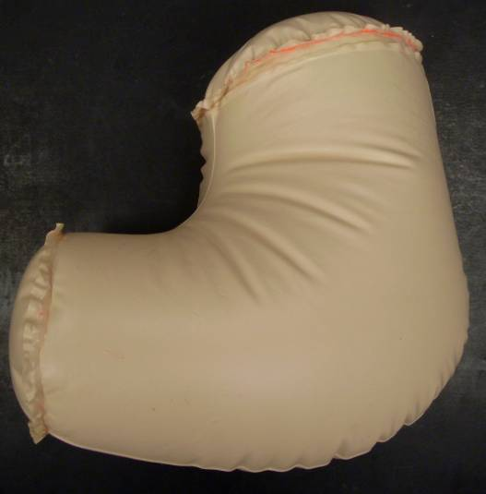
Figure 1. Coarse female pelvic anatomy retained from the pelvic region of the inflatable novelty doll sealed with vinyl adhesive in the waist and thigh regions.
Platsil gel 10 by SmoothOn is the silicone used to mold the external tissue near the vagina opening. This product is typically used in facial prosthetic. To create distinction between the thicker labia majora and thinner, more flexible labia minora, different compositions of Platsil gel 10 part a, part b, and deadener are used. The silicone mixture of the labia majora is 2:2:1 of part A: part B: deadener. The labia minora and clitoris were molded from 1:1:2 of part A: part B: deadener. To create further distinction, different colors were also used for labia majora, labia minora, and clitoris.
A plastic anatomically correct model was used to create a negative mold of the tissues near the vagina opening of the model. Red wax was applied liberally to the anatomical model, followed by pouring of liquefied plaster which forms the negative mold. Colored Platsil gel 10 with composition mentioned above was then poured into the negative mold and let cured at room temperature over night. Attachment of the molded external tissue to the vagina opening of the inflatable portion is done by sewing the silicone part to a sheet of vinyl. The vinyl sealant was then used to attach the sewn on vinyl layer to the rest of the inflatable portion.
The ability to deflate the model after each use provides the advantage of very small storage volume for the ease of transportation. The minimum dimension of a properly folded and deflated gross anatomy portion of the model is 6.5 x 2.5 x 2 in³. Figure 3 shows the inflatable portion of our design, equipped with dimension relative to the vagina opening.

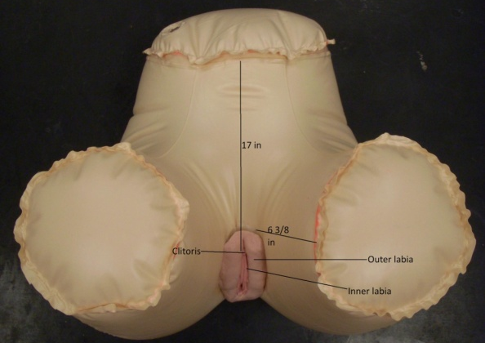
Figure 3. Inflated coarse pelvic model with the external vaginal tissues attached to the correct position. Dimensions are included for reference.
Transparent visual aid. A transparent silicone masturbation sleeve was purchased from a local adult entertainment store (Figure 4). An FC with dyed inner and outer ring is placed properly within the masturbation sleeve, with the inner ring rests at the closed end of the sleeve (cervix) and the outer ring rests at the opening of the sleeve (labia majora). The dyed rings were meant to create contrast between the transparent sleeve and opaque FC and for easier visualization during use in a larger class room.

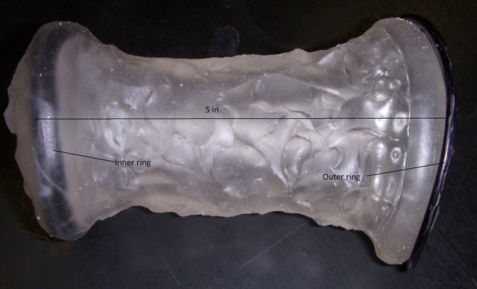
Figure 4. Transparent silicone masturbation sleeve with dyed FC properly inserted to indicate the correct location of the inner and outer ringers when FC is correctly inserted. Dimensions are included for reference.
Accessories. Due to the inflatable nature of the model, we included an athletic hand pump to accompany the female condom teaching model. The total weight of inflatable portion, masturbation sleeve, and the hand pump comes down to 345 gram, which is well under the restriction of one kilogram.
Cost. The prototype cost comes down to $55.00. This price includes the inflatable novelty doll, transparent masturbation sleeve, athletic hand pump, and two tubes of vinyl sealant used in constructing the model. Not included in this figure is the donated Platsil gel 10 and labor cost of a local medical artist. We expect that this figure would be significantly reduced during mass production.
Testing
Physical Testing. The most critical aspect of ensuring the viability of our model was the tightness of the seal for our inflatable vinyl pelvic frame. We tested the efficacy of the seal by inflating the model using the hand pump device. Air flow or leakage and deflation of the model would indicate the existence of holes in the seal.
Educational Testing. The most important aspect of this device is its ability to serve as an educational tool that enhances audiences’ knowledge of how FC is correctly and effectively used. In order to test the instructional efficacy of the prototype, surveys were developed for students in the basic and advance HIV/AIDS Temporary Issues classes at the University of Wisconsin-Madison. Since the students in these two classes will be the primary beneficiaries of the finished model, it was important to determine if their knowledge is improved if they were taught with our prototype as a visual aid compared to the traditional method of using illustrated pamphlet. Students participated voluntarily and anonymously with zero risk or incentive that could affect their final grades. There were two parts of the testing survey that students participated in: the written section and the hand-on demonstration section. The number of students who completed the written test was 21. This population represented 35 percent of the total students in the two classes (a total of 64 students in both classes). There were 14 students who participated in the hand-on demonstration test. Both written test and hand-on demonstration were performed in house after consultation with the class instructor, Marge Sutinen and William Murphy from the Department of Biomedical Engineering.
The students were divided randomly into a control group and an experimental group. Both groups were given the same presentation about FC, why and how it was used. However, for the control group, the presenter demonstrated how FC was inserted using hands and pictures that were provided by the FC Company [1]. On the other hand, the experimental group was exposed to the demonstration using our model as a visual aid. After listening to the presentation, each group took the written test survey. All of the information asked in the survey was included in both presentations. Once the students completed the survey, each individual was asked to perform a hands-on demonstration of how to correctly use FC on our model. They were scored on an all-or-nothing basis. All the questions were designed so that if the students performed a step correctly, the full point was rewarded. Students receive zero otherwise. The results of the written test and hand-on demonstration were tabulated and compared. T-test analysis was performed to compare the scores between control and experimental groups. P value of <0.05 was considered to be significant. The software used for these analyses was the Sigmastat version 3.5.
Results
Physical Result. After the final construction of the coarse pelvic model, it was inflated with the hand-pump device and showed no air leakage. It was noticed that the model started to deflate after 24 hours.
Educational Result. There were three main results that could be concluded from the testing. The first set of questions and their results are listed in Table 1. These questions asked for the students’ preference of the use of visual aids. The mean score for each question was compared between the control and the experimental groups using T-test. It was shown statistically significant (P<0.001) that the students preferred the use of the model as demonstration for the female insertion. Also, it enhanced their confidence in practicing using the female condom on the prototype. (Figure 5)

Table 1. Four opinion-based questions with the scoring 1 to 5 from the test subjects. Numbers represent average score ± standard deviation.
Questions | Control Group (n=10) | Experimental Group (n=11)
1) The visual aid helps you in visualizing the process of using a FC (1=least significant; 5= most significant) | 4.73 ± 0.47 | 3.2 ± 0.88
2) The visual aid helps you to visualize and locate anatomical structures (1=least significant; 5= most significant) | 4.45 ± 0.69 | 2 ± 1.05
3) After seeing the presentation, how confident are you in doing the demonstration on how to use FC? (1=least confident; 5= most confident) | 4.09 ± 0.83 | 2.6 ± 0.84
4) After seeing the demonstration, how confident are you in practicing using the FC? (1=least confident; 5= most confident) | 3.82 ± 0.85 | 2.8 ± 1.03

Figure 5. Average score (y-axis) of test subjects to the opinion questions, indicating the female barrier model users believe that our model is more effective in visualizing the use of FC compared to traditional no-model presentation (SE as error bar; p < 0.05 for all 4 questions; n_{with model} = 11; n_{without model} =10)
The second part of the written survey tests the students’ general knowledge of the female condom. The maximum point of 8 indicated thorough understanding. Since all the information needed to answer these questions was included in the presentation exposed to both groups, the difference in the mean of total scores between the control and experimental populations was not significant. The questions and scores in part 2 could be found in Table 2 and Figure 6.
Table 2. Knowledge-base questions and the correct/suggested answers:
- The outer ring of FC is (thicker, thinner) and needs to stay (inside/outside).
The inner ring of FC is (thicker, thinner) and needs to be placed on (inside/outside)
- What kind of lubricant can be used with FC?
  - Oil based
  - Water based
  - Silicone based
  - All of the above
- Name 2 common mistake made while using FC
  - The inner ring of the female condom does not rest in the cervix
  - The whole condom when inside
- Which of the following can never be done when using a FC during intercourse?
  - The use of male condom and FC together
  - Using water based lubricant
  - Using spermicide
  - All of the above
* Note: Bolded answers are correct answers

Figure 6. Knowledge quiz indicated no statistically significant difference between the control group (average 5.64±1.50) and experimental group (average 5.00±1.94) improvement in factual knowledge of FC use. (Average score with SE as error bar; p =.409; n_{with model} = 11; n_{withoutmodel} = 10)
The most important section of the testing was to determine if the students show significant improvement in their skills of FC installation. The criteria used to evaluate the subjects’ performances during FC insertion performance testing were included in Table 3. The maximum obtainable score was nine, and the minimum was zero. T-test was used to analyze the mean scores between the control and the experimental group. The result was statistically significant (P<0.05), indicating that the students in the experimental group demonstrated better FC installation skills after using our model (Figure 7). This finding indicated that the model had a significant and positive impact on group presented with our model.
Table 3. Grading rubric of the hands-on demonstration of FC installation using our new model.
 | Skills to be demonstrated
Does the student correctly follow the steps of inserting FC? | - Student squeezes the inner ring to make oval shape and inserts it as far up as it can go (+ 3)  - Student pushes up the female condom untwisted with a couple of fingers (+3)
Does the student correctly dispose the FC? | - Student squeezes and twists outer ring and pull out with gentle yet swift motion (+3)

Figure 7. Technique test indicated a statistically significant difference between the control group (average 5.57±3.64) and experimental group (average 9.43±2.07), with the experimental group scoring higher than the control group. (Average score with SE as error bar; p < .05; n_{with model} = 7; n_{wihtout model} = 7)

Discussion
We have constructed human female pelvic model accompanied by a separate transparent masturbation sleeve to educate the users how to properly install FC and how an accurately installed FC should appear in a life setting. This device is quiet distinguishable from the existing products and potentially provide a higher educational value. Most current models lack the ability to fully address the actual anatomy and the relative positions of the anatomical landmarks in the pelvic region, which makes it difficult for students to relate the model to the actual human being. While some of the models might contain several important anatomical landmarks such as the labia majora and the vaginal opening, the length of vagina is relatively shorter than the actual human being’s which again makes it difficult for the users to completely practice and visualize the exact view of the properly installed FC. Our light-weight model allows for easy transportation, provides an overall gross anatomy of the pelvic, and also gives similar flesh texture to the major anatomical landmarks.
T-test analyses of surveys of 21 subjects indicated that the students exposed to the new model scored approximately 1.6 points higher on a 5-point scale than the students who were taught with illustrations only. Moreover, students who were exposed to our model performed better on the hands-on testing by demonstrating the complete proper FC insertion with the new model compared to the group that had no previous experience with the new model. Therefore the scored data and hands-on demonstration supported the conclusion that the usage of the new female barrier teaching model educates the users more effectively than the traditional teaching method. However, surveying the students was done immediately after the exposure of the students to our new model, while the teaching was still fresh in mind. If possible, further testing could be performed on the users several weeks after the exposure to the model. Also we experienced a loss of test subjects for the hands-on testing (14 subjects total, compared to the initial 21) due to time issues.
Although this new anatomically correct model provides a new perspective to the education of female barrier installation, there still exist several areas for improvement, providing an opportunity for future works. For instance, the current material of the labia is made of prosthetic silicone and the pre-lubricated FC contains silicone lubricant. The liquidated silicone lubricant could potentially erode the solid silicone of the labia on the model which eventually damages the model. It would greatly improve the sustainability of the model by finding a replacement for the silicone tissues. Moreover, it would be necessary to test the mechanical properties of the model to examine its performance in various conditions. Since this model could be potentially used world wide to teach FC insertion to prevent STD infection, the teaching environments and weather of different countries also need to be considered. The mechanical strength of the vinyl plastic gross anatomy needs to be assessed in order to verify the different weathering conditions do not distort the anatomy nor degrades the plastic which would result in toxic chemical release. We hope to optimize the material to provide a longer lasting usage life of this female barrier teaching model.
Acknowledgement
We would like to acknowledge Mr. Greg Gion for the help in the manufacturing of the external tissues; Dr. Bersu for the anatomical pelvic model; students in the HIV/AIDS Advance class for their fundraising effort; Jenny for her willingness in educating us about Female Condom; Sex Out Loud Organization for their generosity in providing us their tools; and Red Letter News for their kind discounts
Reference
[1] The Female Health Company. (http://www.femalehealth.com)
[2] Stanecki, K. (2004) The AIDS Pandemic in the 21st Century. U.S. Census Bureau
[3] World Health Organization (2001). HIV/AIDS in Asia and the Pacific

