**University of Wisconsin - Madison**

Face Neuromodulation Stimulator

08

**Fall**

### Lauren Eichaker - Communicator

### Kim Kamer - BSAC

### Kenneth Xu - BWIG

### Laura Zeitler - Team Leader

### Client: Dr. Kurt Kaczmarek

### Advisor: Dr. Walter Block

December 9, 2009

Table of Contents

Abstract 3

Background 3

Electrotactile Stimulation 3

Current Rehabilitative Techniques 4

Trigeminal Nerve 4

Problem Statement 5

Competing Designs 5

Design Criteria 6

First Prototype 7

Second Prototype 7

Third Prototype 8

Final Testing 9

Safety and Ethical Considerations 9

Testing 10

Future Work 13

Conclusion 15

References 16

Appendix A: Product Design Specifications 18

Appendix B: Costs 20

# Abstract

Neuromodulation uses the mechanism of brain plasticity to modify and recruit new neural connections to compensate for loss of motor or sensory function with other areas of the brain. One way to catalyze the formation of new connections is through electrotactile stimulation. Stimulation of the tongue in this manner has shown promising rehabilitative results for patients with balance disorders; however, not all patients are able to hold a tongue stimulator in its proper position. Therefore, a face mask design that stimulates the same neural bed was requested. The final prototype of our face mask design was made of flexible silicone specifically molded to a specific subject’s face. Testing of this prototype was performed to determine the reproducibility of the threshold stimulus (the minimum stimulus required for the subject to feel stimulation) for each electrode. Results were that the prototype met our goals, having a low standard error of less than 20% of the threshold stimulus for 34 of the 36 electrodes. Future work includes using MRI to obtain a 3D image of the face in order to obtain a more accurate face mask and using liquid silicone molding, rapid prototyping, or an alginate mold to make the silicone mask.

# Background

Neuromodulation is the electrical stimulation of a patient or the administration of drugs to a patient for the purpose of modifying a function. Tactile stimulation to transmit information to the brain's electrochemical environment is the main neuromodulation therapy used in rehabilitation. Neuromodulation occurs naturally in the brain and sees enhancement by such external influences as psychoactive drugs and stress, but can be regulated through random patterns of electrotactile stimulation which induce brain plasticity (TCNL 2009). Brain plasticity can be defined as a neural quality that clinicians and researchers can use to fill “gaps” in the nervous system and reroute the nerves to form new, stronger connections when other nerves have been damaged or diseased in that area (Doidge 2007).  External electrical stimulation, neuromodulation, and brain plasticity have been connected through extensive research and researchers have extended these concepts to the therapeutic enhancement of lost sensory function.

## Electrotactile Stimulation

           Individuals who lose sensory perception have few options to regain that function due to the current lack of understanding. However, one option to improve the lives of these individuals is a sensory substitution system, for which current research is cutting edge. Alternative sensory channels that have been used include the eye, ear, tongue, and skin. Investigators believe that an electric current passing through the skin directly stimulates afferent nerve fibers or receptors.  Subjects describe electrotactile sensations qualitatively as a range from a tingle or vibration to a burning pain, depending on the properties and contact of the electrode and the pulse intensity it delivers (Kaczmarek *et al.* 1991).

## Current Rehabilitative Techniques

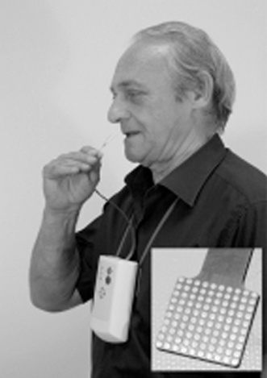        Previous attempts to improve lost functions in balance, vision, and hearing through sensory substitution have proved successful, including stimulation of the tongue to improve balance in individuals with vestibular problems. During previously conducted research sessions, subjects placed the end of a flat, flexible, 3 cm wide strip of plastic cable into the mouth (Figure 1). This plastic cable is made of a thin (100 μm) strip of polyester material (Mylar®) and is placed 5 cm into the mouth so that it contacts the upper surface of the tongue.  The strip, held in place by the lips, allows for the deliverance of an electrotactile stimulus via a 12x12 rectangular array of gold-plated copper, circular electrodes (1.5 mm in diameter) created by a photolithographic process similar to that used to make printed circuit boards. Each electrode in the device is stimulated with a current, with the other electrodes returning the current serving as a virtual ground. Random patterns of electrode stimulation applied to the tongue, thought to invoke the concept of brain plasticity by stimulating the trigeminal nerve (*vide infra*, Trigeminal Nerve), allowed individuals to “re-learn” balance therapeutically. The therapy sessions, about a half hour in length over a period of many weeks, resulted in rehabilitation until stimulation was no longer needed.  Kaczmarek *et al.* (1991) observed promising results in patients displayed by the continued demonstration of improved balance even after the removal of the device. The client wishes to explore other regions where electrostimulation might be applicable.

*Figure 1:* Subject using tongue stimulator including a 3 cm wide plastic cable with 12x12 copper electrode array (Kaczmarek *et al.* 1991).

## Trigeminal Nerve

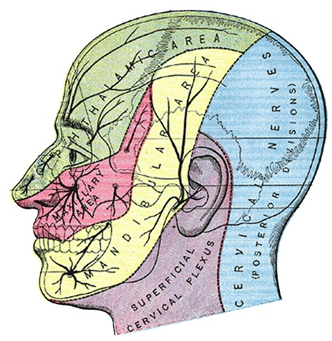       The trigeminal facial nerve is stimulated through the tongue stimulator (Figure 2). It is composed of three large sections: the ophthalmic (sensory), maxillary (sensory) and mandibular (motor and sensory) branches.  It functions both as the chief nerve of sensation for the face and the motor nerve controlling the muscles of mastication.  The ophthalmic nerve serves the skin on the upper eyelid, forehead and the scalp above the eyes up to the vertex of the head.  The maxillary nerve serves the upper lip, lateral surfaces of the nose, lower eyelid, conjunctiva, the cheek, and the temple region.  The mandibular nerve innervates skin over the lateral and anterior surfaces of the mandible and the lower lip (Trigeminal Nerve 2009).  Based on the previous research and therapy executed with the tongue stimulator, it is believed that the tongue stimulator affects the mandibular branch of the trigeminal nerve. Due to the anatomical position of this nerve, our design is likely to also stimulate the mandibular branch because the face and tongue are innervated by the same branch of the trigeminal nerve (Tyler 2008). By utilizing our device, the client may investigate the effect of stimulating not only the mandibular branch (as with the tongue stimulator), but the other branches of the trigeminal nerve as well.

*Figure 2:* The trigeminal nerve covers the face shown here as the green, red, and yellow areas (Britannica 2009). In yellow is the mandibular branch which is thought to be stimulated by both the tongue and face stimulator (Tyler 2008).

## Problem Statement

Neuromodulation resulting from electrotactile stimulation can be used in rehabilitative therapy for treatments of neurological disorders such as Multiple Sclerosis, Vestibular dysfunction, and Parkinson’s disease. Random stimulation of the tongue in conjunction with performing difficult physical tasks has shown promising results in reversing the negative effects of these disorders through the use of brain plasticity. The tongue stimulator is not acceptable for use by all patients and so other stimulation locations, such as the face, are being explored. A prototype that is cost effective, safe, and electrically predictable is needed to test the possibility for success with facial neuromodulation therapies. If stimulation of the face proves successful, then the treatment application base will be broadened to patients who are unable to hold a device in place by themselves.

# Competing Designs

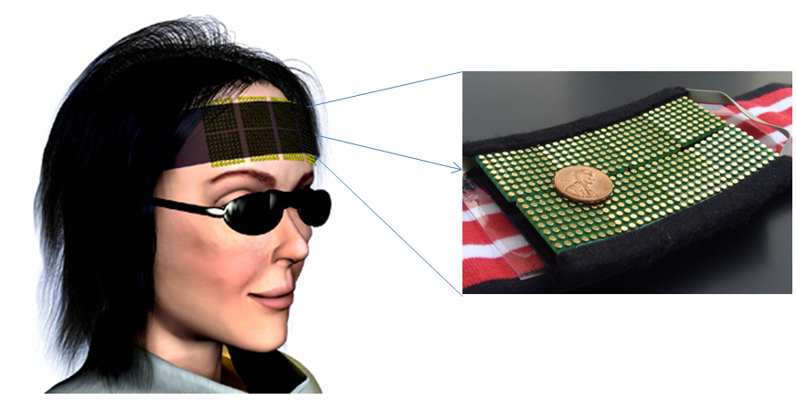 The forehead electrotactile display developed by Kajimoto *et al.* (2006) utilizes electrotactile stimulation in order to assist patients with vision replacement. Their design includes an electrode array of 512 electrodes placed on the forehead as shown in figure 3. In order to reduce the resistance of electrical contact between the electrodes and they skin, they use a conductive gel in the interface. Their results show that this is effective. However, this design is not ideal for facial stimulation because it only covers the forehead. This forehead design was not intended for neuromodulation purposes, while our design is intended for neuromodulation.

*Figure 3*: Competition for facial stimulation involves a forehead stimulator model made for vision replacement. The unit is wrapped around the head and uses a conductive gel in the electrode-skin interface in order to ensure optimal electrical contact where mechanical contact by itself is not sufficient.

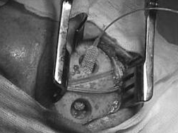Another competing design uses extradural motor cortex stimulation (MCS), which was designed initially for neuropathic pain, for the treatment of movement disorders. The application focuses on post-stroke involuntary movements but can also be used for balance disorders. It was shown that Parkinsonian tremors were lightened through the use of MCS. A seven contact electrode plate is placed on the brain cortex between the motor and sensory regions and stimulation is set at 60 Hz (Figure 4). This design has no accompanying mortality and very low injury rate. However, the surgery is highly invasive and the implanting process is dangerous. Adjustments of the device also prove to be difficult once the healing process has started. Finally, even with high associated costs, rehabilitation is not guaranteed (Canavero *et al.* 2003).

*Figure 4*: Extradural cortical stimulation is a competitive treatment for balance disorders that is highly invasive and involves the implantation of electrode paddles directly onto the cortex with current stimulation at 60 Hz (Canavero *et al.* 2003).

# Design Criteria

The device must feel comfortable during its use for a period of thirty minutes during the treatment sessions. These treatment sessions may occur once a week. A limit of 250 grams for the mass of the final design (which is around the weight of 2 baseball caps) was thus implemented so that the patients’ necks would not fatigue. The durability of the mask must also be sufficient so that it would last at least one year without significant wear that would hinder its performance.

The mask’s medium must be able to withstand the perspiration from the patients face and have some method of sweat retention so that the sweat would increase the conductivity between the face and electrodes. This perspiration would act in addition to the patients’ faces being wetted with water before use so that the moisture level of the face is elevated.

Electrodes inserted into the mask must have a smooth, round head so that the current does not collect at the edges and cause a painful sensation. They must also be made of a completely non-toxic, hypoallergenic material that does not interact with the skin in a negative manner with applied current. Common safe materials include gold, stainless steel and platinum.

Overall, the most important requirement for the mask is that the embedded electrodes must have reliable electrical contact. This consideration requires our design to have good mechanical contact of the device to the face, which, in turn, would make good electrical contact possible. Electrical safety is also a primary concern. The current applied to the patient’s face must be under 10 mA and there must be a method to ground the electrodes. Finally, the total cost should be under $3000 (Appendix A).

# FACE MASKFirst Prototype

The first prototype was constructed from silicone using two purchased plastic masks as the positive and negative molds. It contained 18 electrodes that were evenly placed about the mask. The electrodes were u-drive screws, which are smooth, rounded-top screws. The screws used in this prototype were 9.53 mm long and had a 3.20 mm head diameter. Because the masks we used for the molding were purchased off-the-shelf, they were nearly identical and thus the molding process was simple and produced a smooth mask. The prototype cost $72.23.

Because insufficient silicone was used, the mask did not completely cover the surface of the face (Figure 5). Also, this first attempt was not tailored to any one person’s face, so the product did not fit any of our group members’ faces well. Finally, the rigid-cure silver conductive epoxy and the method of application used proved problematic. For the electrode-wire connections, we first wrapped the wire around the electrode and then applied the epoxy. We determined that this method was insufficient when the wires were oscillated because resistance testing showed a ±2 Ω difference. This resistance change is low compared to the 10 kΩ resistance expected at the electrode-skin interface.

*Figure 5:* The silicone face mask design involves making a generic mold out of silicone. The electrodes are u-drive screws connected to wires with silver conductive epoxy.

# Second Prototype

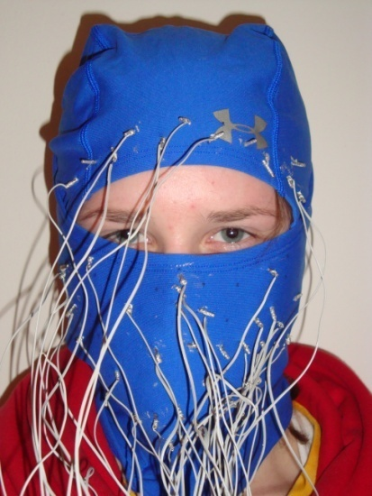The second prototype involved a different material to determine if sufficient mechanical contact of the electrodes with the skin could be attained (Figure 6). A polyester and elastin ski mask of the brand name Underarmour® (Underarmour, Baltimore, MD) was used as the mask substrate. During prototype construction, 50 u-drive screws (9.53 mm long and 3.20 mm in head diameter) were manually pushed through the fabric material with electrode heads facing the inside of the mask. Wires were secured onto the tail of the electrode with rigid-cure silver conductive epoxy by applying epoxy to the wire prior to wrapping it around the screw. This prototype was the most cost-effective, costing about $46.38 and was also the most lightweight. The design was an improvement upon the first prototype because no external strap attachment was required to hold the electrodes onto the face.

*Figure 6:* The polyester/elastin ski mask design does not conform to concave areas of the face. The 50 electrodes are u-drive screws connected to wires with silver conductive epoxy.

Unfortunately, the team found that the ski mask design did not adequately cover all areas of the face, especially the lower forehead region and the area near the eyes. The elastic fabric also did not conform to all areas of the face, including the concave areas of the cheeks next to the nose and areas directly surrounding the mouth. Electrodes were not placed in those areas since they would not contact the skin. Additionally, some regions of the face, such as the nose, experienced a greater force from the electrodes than other areas, like the sides of the cheeks. In addition to flaws of the overall design, construction of the prototype proved inadequate: the team discovered that even slight movements caused the electrodes to fall through the fabric and caused the wires to separate from the screws. Finally, this prototype did not lend itself well to reproducible testing results because of the inherent difficult and variability of applying the mask to the face. The mask was difficult to slide over the head without disturbing the electrical connections, and the electrodes rested over different locations of the face each time the mask was reapplied. The universal fit of this prototype is a strong benefit. However, the downfalls include the lack of contact in some areas coupled with the difficulty of putting the mask on and taking it off which led us to construct a third prototype.

# Third Prototype

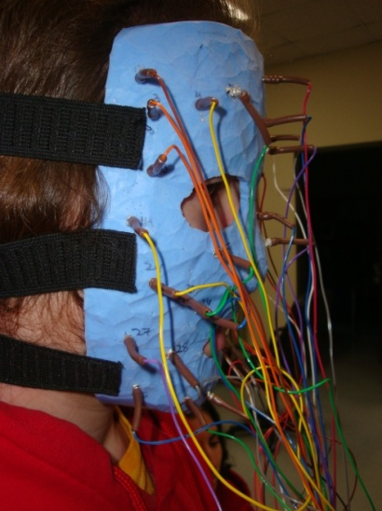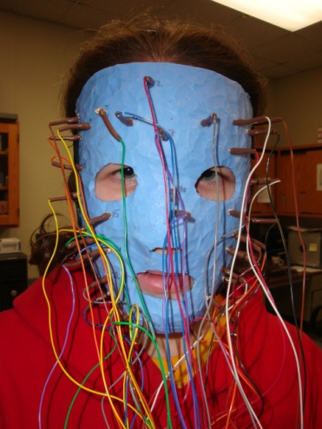Our third prototype was an improvement over the first prototype (Figures 7 and 8). It also contained a silicone base for the mask material. First, two plaster replicas of a team member’s face were created using plaster gauze. The strips were smoothed directly onto the subject’s face after dipping them in warm water. After the entire face was covered, the plaster dried for 15 minutes. Two polypropylene plastic molds were created from the plaster mask using the CAM Central 1620 Lab Thermoforming Machine model 1620250. The two finished plastic molds fit inside each other, so that silicone could be poured between them in a sandwiching style. Unfortunately, the molds did not fit together perfectly, and the initial silicone mask was much thicker than had been intended. Thus, the team used a razor blade in combination with a table sander to remove as much of the excess silicone as possible, bringing the final prototype mass down to approximately 200 g. Holes drilled using a hand-held drill allowed for the insertion of the 36 u-drive screws (length 15.88 mm and head diameter 7.85 mm), which were manually pushed through the silicone with the heads facing the inside of the mask. Prior to connecting the wires to the screws, tubular, inactivated strain relief guards (about 3 cm in length) were slid over each wire. Flexible silver conductive epoxy was then used to secure wires to the screws by applying the epoxy to the wires prior to wrapping the wires around the screws. Finally, a heat gun was used to activate the strain relief guards, shrinking them around the electrode-wire interface to secure the connection. Three elastic bands (25 mm wide) were sewn onto the mask itself using thread (Figure 7). The final prototype cost is estimated at $97.44 (Appendix B).

*Figure 7: Side view.* The final silicone face mask used three 25 mm width elastic bands to secure the mask to the face. The electrodes are 7.85 mm diameter u-drive screws connected to wires with flexible silver conductive epoxy.

*Figure 8: Front view.* The final silicone face mask design involves making a user-specific mold out of silicone. The electrodes are 7.85 mm diameter u-drive screws connected to wires with flexible silver conductive epoxy.

This prototype was a significant improvement from our previous two attempts. It more accurately and comfortably conformed to a subject’s face, as it had been custom fit during the manufacturing process. The electrical connections proved more stable using the flexible epoxy, and the strain guards also reinforced the wire-screw bond. The mask was not difficult for the subject to put on and take off. Error in the fit of the silicone mask arose from the multiple molding processes that we created from the face, including plaster and plastic intermediates. Also, the mask only fit one subject’s face and was extremely uncomfortable for other group members to wear. Therefore, we were only able to test with one subject.

# Final Testing

## Safety and Ethical Considerations

Our device should have very similar standards and safety protocols as the tongue stimulator. Therefore, like the tongue stimulator, it should not need FDA approval because it is considered a non-significant risk (NSR) experimental research instrument (Tyler 2008). This device is intended, at this early stage, to be used only on healthy human subjects in an experimental research environment. In addition, safety is ensured by the voltage application limit (up to 40 V), which is converted to current in order to guarantee that no more than 10 mA can be sent to the electrodes (Tyler 2008). Because our device would be stimulating the same nerves using the same stimulation setup, no new concerns arose from those of the tongue stimulator from experimental use. In fact, in their several years of experience, the investigators using the tongue stimulator have never observed adverse effects (Tyler 2008). One new concern, however, is the possible reddening of the skin under the electrode after stimulation. Such observations have been noted in some subjects after using an abdominal stimulator, but the reddening has subsided after no more than an hour (Tyler 2008). Finally, the setup, as with the tongue stimulator, utilizes coupling capacitors in series with the electrodes being stimulated in order to ensure that there is no net dc current at the output (Tyler 2008).

## Testing

In order to determine the success of our final prototype, we performed threshold stimulus reproducibility testing. The threshold stimulus is the minimum stimulus intensity necessary for the subject to feel the stimulation. In this testing, the subject put the mask on and one electrode was stimulated individually, while always controlling the current. The setup is shown in figure 9: the electrodes are connected to the tongue display unit (TDU), which interfaces with a custom-made computer program. The TDU is then connected to a voltage-to-current converter. This setup uses the same safety controls, equipment, and software that were used for the tongue stimulator. The operational limits include a 40 V maximum, which corresponds to a current of 10 mA when it gets to the electrode (Tyler 2008). The voltage-to-current converter ensures that the amount of current sent to each electrode is controlled at all times, and not exceeding 10 mA for safety purposes.

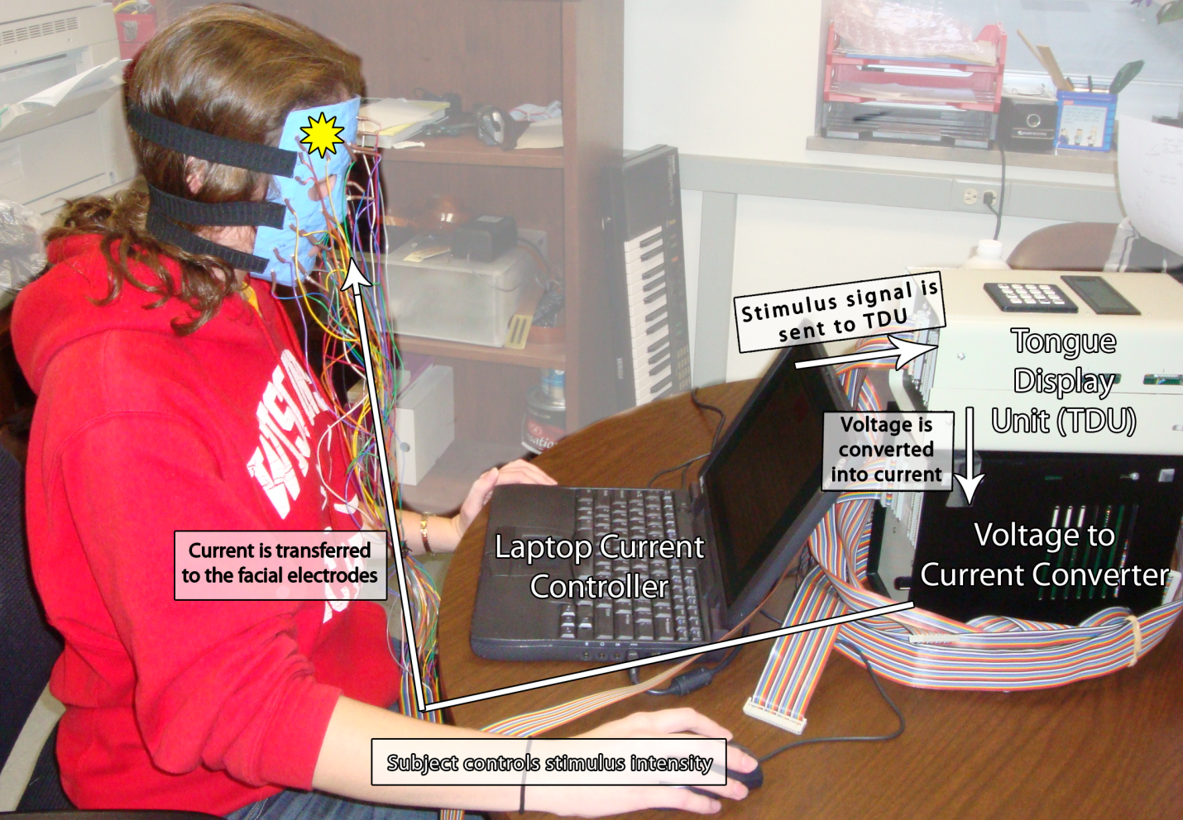

*Figure 9*: Stimulation threshold reproducibility testing procedure setup is shown here. In testing, the subject controlled the stimulation intensity of each electrode individually and the device was current-controlled to ensure safety. The electrodes are connected to the tongue display unit interfacing with a custom computer program, which is connected to a voltage-to-current converter. This same setup has been used successfully for the tongue stimulator.

The final prototype was tested on the same individual for whom the mask was custom-fit.  Testing on multiple subjects would provide information on inter-individual differences in the threshold of stimulation.  However, due to shape differences of the face, the electrodes over the nose pushed into the skin painfully on the two other potential subjects.  To obtain threshold information on differences between individuals, masks need to be generated separately for each subject.  This would require additional time and resources. If the threshold stimulus had the greatest reproducibility for the subject that the mask was intended for, we could conclude that the mask had good specificity. It would be ideal to run a statistical analysis of variance (ANOVA) test between the three subject’s data; however with only one replicate, this is impossible for us to carry out.

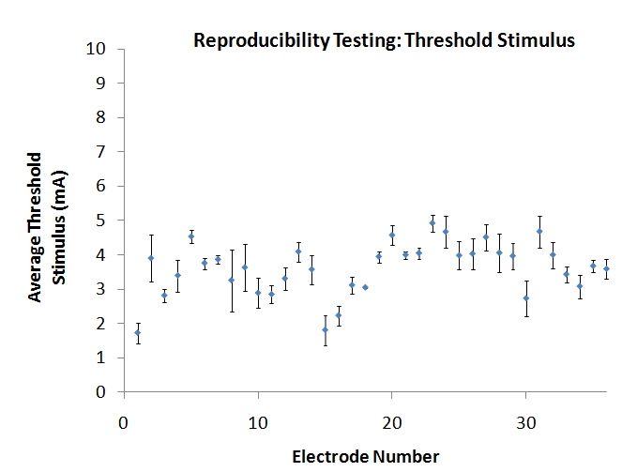 We performed threshold stimulus reproducibility tests at each electrode individually by letting the subject gradually increase the current sent until stimulation was perceived. Then, the threshold stimulus was recorded for each electrode. This test was done for each electrode three times, while intermittently removing the mask for 10 minutes in between each test. Results of these tests are shown in figure 10. The range of threshold stimuli for all 36 electrodes was 1.2-5.3 mA with an average standard error (SE) of 0.345 mA. The SE for all but two electrodes (#8 and #15) was smaller than 20% of the average threshold stimulus. In figure 11, the location of each electrode is shown on the face with the corresponding number along with the relative SE indicated for each electrode. The most reproducibly threshold stimulus (the least standard error) was found in the electrode near the subject’s left eye (#18, in red) and the least reproducible (most standard error) was found in an electrode near the middle of the forehead (#8).

*Figure 11*: Positioning of the electrodes on the subject’s face, indicating where each electrode touches and the relative standard error (SE) in the three separate threshold reproducibility tests (shown in Figure 10). The scale is shown to the left, with red representing least SE and purple, most SE.

*Figure 10*: The face mask was placed on the subject’s face three separate times and each electrode was stimulated individually to the minimum threshold of current at which the subject noticed stimulation. This threshold stimulus was recorded and the average of the three replicates is plotted above (±1 standard error [SE]). The range of threshold stimuli for all 36 electrodes was 1.2-5.3 mA with an average SE of 0.345 mA.

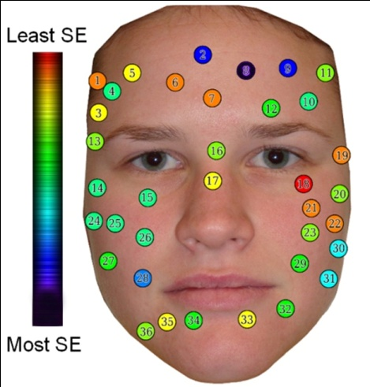

There may be several reasons to attribute this variability amongst the three trails. First, our prototype construction may be a reason for error. The mask did not have consistent contact over all areas of the face. Not only were some areas of the mask not touching the face, but also some of the electrodes applied more force than others. Force between the electrodes and the face, therefore, could be a useful measure in the future (*vide infra*, Future Work). If some electrodes, such as #18, had better contact with the face, over #8, that may be a reason for increased standard error. In addition, Kajimoto *et. al* (2006) found that the nerve depth and diameter strongly affects the current threshold. The thickness of the skin is also an important factor for the current threshold and can vary throughout the face (Kajimoto *et. al* 2006). Therefore, if the electrode changes position even a small amount, the thickness of the skin and the nerve depth and diameter may change and affect the threshold stimulus. Finally, the amount of perspiration and the skin type affect the electrical contact and the resistance in the electrode-skin interface, which could change the stimulation threshold (Schaning and Kaczmarek 2008). Due to these reasons, we decided up to 20% SE would be acceptable for our prototype.

# Future Work

Although our final prototype met the goals stated by the client and set by the team, we acknowledge that improvements to both our design and methods can be made. By utilizing outside fabrication techniques and experimenting with alternative materials, the team can make improvements upon this semester’s final design.

Magnetic resonance imaging (MRI) may be used to produce high quality images of the human body; a 3D mesh model can be created in 3 main steps. The MRI scanner contains a magnet, which is used to generate a magnetic field 10,000 times greater than the Earth’s. The magnetic field forces hydrogen atoms in the body to line up such that when radio waves are sent toward them, the waves bounce back. A computer records the signal; as different types of tissues send back different signals, a “slice” of the body may be recreated. By putting together the slices, a human body or part of a body can be depicted (HowStuffWorks 2009).

Using the MRI, applications of non-contact, reverse engineering may be used to generate a physical replication. Using MRI provides the means to dramatically reduce the lead-time required to produce a prototype: in a matter of hours an MRI can be done and converted to a computer-aided design (CAD) drawing. The team contacted several companies to find out how this process is executed today. At Biomedical Modeling Inc. (BMI), MRIs are used to create a series of very thin layers of resins or other specially engineered materials. The quality of the physical piece is determined by the contrast of the optical images; a computer guides the process (Weinberg 2004). A second example, Axia 3D Design Group, also specializes in rapid prototyping strategies. This group uses a detailed 3D image, and in-house software to convert data files obtained into printable files. These files are then “printed,” using their Fuse Deposition Modelling (FDM) 3-Dimensional printer, in acrylonitrile butadiene styrene (ABS) plastic. They currently specialize in custom implants (Kirsley 2009).

Inquiries aimed at both of these parties resulted in estimates pertaining to the fabrication of a 3 mm thick, silicone or flexible resin replica of a human face costing between $1,000 and $2,000. By outsourcing this aspect of the team’s design to a company that specializes in the task of creating a mold of a subject’s face, the team would be able to achieve greater accuracy and reduce the time and steps required for fabrication.

Another way to specifically transition from the CAD file generated from the MRI to a silicone mask is to use liquid silicone molding. The prototyping facilities at Albright Technologies in Leominster MA offer the ability to produce a quick model using an efficient tooling and machining process (Liquid Silicone Molding 2008). The molding involves the mixing of silicone and a platinum based catalyst that is injection molded into a heated cast where vulcanization takes place. Albright specifically focuses on prototype molds and also offers a custom pigment selection, which would give us the flexibility to match mask colors to patient’s skin tone. The mask would likely cost about $2000 depending on surface area and complexity of design.

Instead of sending the CAD file to Albright Technologies to make the silicone mask for us, we could mold the next prototype ourselves, enabling us to save a great deal of money. To do this, we could use the rapid prototyping printer in the Digital Media Center at the Biotechnology Center of the University of Wisconsin-Madison to make a negative and positive mold to pour the silicone between. This machine takes the digital modeling information from the CAD file and creates the mold by applying proprietary plaster powder in layers. After completion, the model is coated with cyanoacrylate glue to add strength to the proprietary plaster powder. Based on an estimated 50 square-inch surface area of the face and assuming a final thickness of about 1/8 inch, the cost of a negative and positive mold would be about $100. Therefore, the final prototype could be projected to cost about $860.

Another alternative and inexpensive method for molding the silicone in the future is using a dental molding material called alginate. First, a plaster mask of the subject’s face would be made using plaster gauze. Next, a liberal amount of alginate would be poured into the hardened plaster mask. After thirty minutes, the alginate dries and the silicone pouring process can begin. The alginate mask can be used as the positive mold, and the plaster mask can be used as the negative mold for the silicone. The total cost of this method would not exceed $60.

Further future work could look into the amount of force exerted from the mask on the face at each point in order to assess the success of the design. Limited progress was made in this area this semester. We found a company (PressurEx) that sells pressure sensitive film and obtained a sample of the “Zero” and the “Micro” film. The “Zero” film is meant to measure pressures in a more qualitative manner to compare pressures in different areas. The pressure range of this film is from 7.2 psi to 28 psi. Trying this sample of film yielded inconclusive results due to failure to induce a change in the film with various pressures attempted. The “Micro” film can be used to determine pressure in different areas quantitatively, which would be ideal for this project. The pressure range for this film is 2 psi to 20 psi, which is likely a range of pressures that will be seen in some areas of our mask contact. Preliminary testing indeed indicated that this method might be useful for analyzing the different pressures exerted on different areas of the face. The major drawback, however, is the cost. The smallest quantity of this film that we could buy would be 15 sheets of 17 inches by 11.25 inches for $229. Therefore, the necessity this measurement will need to be determined before purchasing it.

# Conclusion

Our final prototype met our main goals: it can electrically stimulate the face, it conforms to most areas of the subject’s face, and it has stable electrode connections. For these reasons, the team defines the prototype, which contained 36 u-drive screws as electrodes, as a successful endeavor. Additionally, testing proved that our prototype’s threshold stimulus reproducibility had a low SE for most of the electrodes, with only two of the 36 electrodes having a greater SE than 20% of the average threshold stimulus. Despite the success of our final prototype, we look forward to making changes in the future to make our prototype better, including increasing the contact and simplifying the production of our face mask. Some of these changes could include: using MRI to obtain a 3D image of the face in order to obtain a more exact face mask with liquid silicone molding or rapid prototyping or by using an alginate mold for the silicone. Implementation of these modifications has the potential to facilitate rehabilitation research using the face for a neuromodulation outlet.

# References

Canavero, S., Bonicalzi, V., Paolotti, R., Castellano, G.,Greco-Crasto, S., Rizzo,L., Davini, O., Maina, R. 2003. Therapeutic extradural cortical stimulation for movement disorders: A review. *Neurol Res 25:* 118-122.

Doidge, Norman. *The Brain That Changes Itself : Stories of Personal Triumph from the Frontiers of Brain Science.* New York: Penguin Group (USA) Incorporated, 2007.

HowStuffWorks.com. 2009. “How MRI Works.” Retrieved (4 December 2009), from http://www.howstuffworks.com/mri.htm.

Kaczmarek, K.A., Webster, J.G., Bach-y-Rita, P. and Tompkins, W.J. 1991. Electrotactile and vibrotactile displays for sensory substitution systems. *IEEE Transactions on Biomedical Engineering*. 38(*1*):1-16.

Kajimoto, H., Kanno, Y., Tachi, S. 2006. Forehead electro-tactile display for vision substitution. *Proceedings of EuroHaptics,* 75-79.

Kirsley, A. Axia 3D Design Group. 2009. Retrieved (4 December 2009), from http://axia.co.nz/medical.

Liquid Silicone Molding. 2008. Accessed 6 December 2009 from

http://www.albright1.com/molding.php.

National Pain Foundation. 2009. http://www.nationalpainfoundation.org/articles/338/treating-with-neuromodulation?PHPSESSID=c1bb9c1efe33f795b22efd05c68b5183. (Retrieved October 16, 2009).

Schaning, M.A. and Kaczmarek, K.A. 2008. A high-voltage bipolar transconductance amplifier for electrotactile stimulation. *IEEE Transactions on BME,* October 2008.

Tactile Communication & Neurorehabilitation Laboratory at UW-Madison (TCNL). 2008. http://tcnl.med.wisc.edu/home.php. (Retrieved September 4, 2009).

Trigeminal Nerve. *Encyclopædia Britannica*. 2009. http://www.britannica.com/EBchecked/topic/605180/trigeminal-nerve. (Retrieved October 10, 2009).

Tyler, M.E. 2008. Electrotactile information coding in oral and facial tissues. IRB Protocol H2007-0251.

Weinberg, C. Biomedical Modeling, Inc. 2004. Retrieved (4 December 2009), from http://www.biomodel.com.

# Appendix A: Product Design Specifications

**Function:**

Neuromodulation resulting from electrotactile stimulation can be used in rehabilitative therapy for treatments of neurological disorders such as Multiple Sclerosis, Vestibular dysfunction, and Parkinson’s disease. Stimulation of the tongue in conjunction with difficult physical tasks has shown promising results in reversing the negative effects of the disorders through the use of brain plasticity. The tongue stimulator is not acceptable for use by all patients and so other stimulation options, such as the face, are being explored. A prototype that is cost effective, safe, and electrically consistent is needed to test the possibility for success with facial neuromodulation therapies. If stimulation of the face proves successful, then the treatment application base will be broadened to patients who are unable to hold a device in place by themselves, which will illuminate the usefulness of our design.

**General Client Priorities:**

* Good skin contact/ fit contours of face
* Cover entire face
* Easily removable
* Safe materials
* Cost efficient
* Easy to clean

The client requirements were adjusted to these final design requirements.

**Design Requirements:**

1. Physical and Operational Characteristics
   1. *Performance requirements* – Must retain performance for several hours at a time.
   2. *Safety* – Must contain electrode connections safely and compactly.
   3. *Accuracy and Reliability* – Current applied must be less than 10 mA.
   4. *Life in Service* – Must be usable for at least one year-or until rehabilitation is complete
   5. *Shelf Life –* Store in cool, dry environment.
   6. *Operating Environment* – Materials must be able to withstand human perspiration. Should induce a moderate amount of perspiration on subject’s face to ensure conductivity.
   7. *Ergonomics* – Should comfortably conform to face ensuring good mechanical contact and limited sensory obstructions. Must remain attached to face even with movement
   8. *Size* – Must cover entire face excluding eyes, mouth and nostrils
   9. *Mass*– Mask should be less than 250 grams
   10. *Materials* – Must be a biologically and electrically compatible substrate that is flexible. Electrode material must be grounded. Electrodes must be stainless steel, gold, silver, or platinum.
   11. *Electrodes*- Must be larger than 0.127’’, possibly closer or greater than 0.25’’ Must have head that has smooth, uninterrupted surface of metal (avoid such things as grooves).
   12. *Strap Attachments*-Attachments must be applied to the head such that consistent contact of the mask is applied to the whole face considering varying degrees of tension.
2. Production Characteristics
   1. *Quantity* – One, but should be designed with the intent of individualized production
   2. *Target Product Cost* – Under $30,000
   3. *Target Prototype Cost*- Under $3,000
3. Miscellaneous
   1. *Standards and Specifications* – Should allow electrical stimulation of the face
   2. *Customer* – Researchers and clinicians working with patients affected by neurological disorders
   3. *Competition* –Current forehead neuromodulation exists, but application is for vision replacement. Tongue stimulation model exists.

# Appendix B: Costs